**Convolutional Neural Networks**

**Statistical Invariance**

**Link:** <https://www.youtube.com/watch?v=0Hr5YwUUhr0>

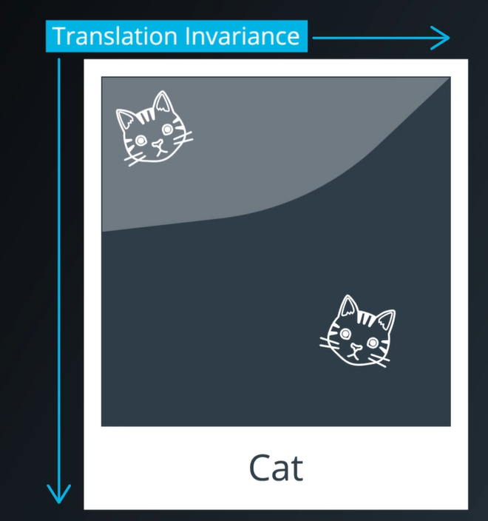

* Vrei sa identifici Pisica din imagine, dar nu conteaza unde este ea pozitionata, ca e in colt sus sau jos. Asta se numeste **Translation Invariance**.

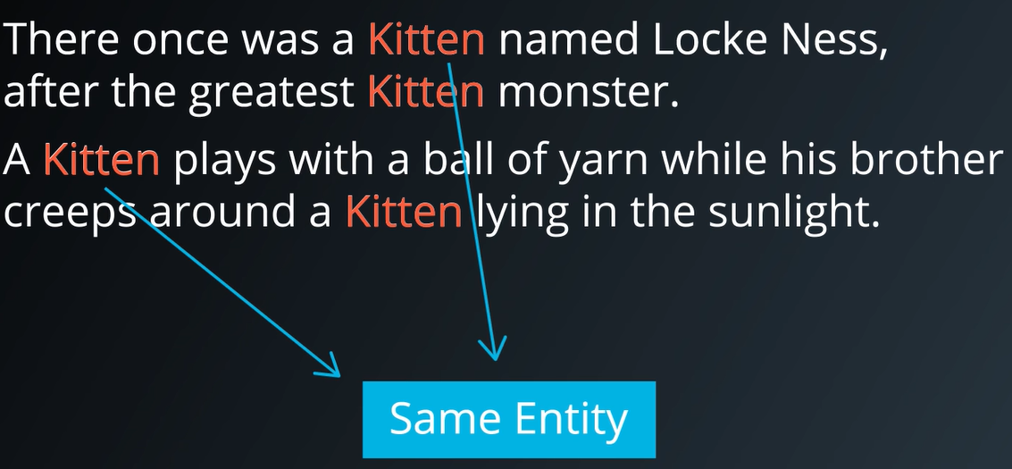

* Acelasi lucru si daca vrei sa identifici Kitten dintr-un text.

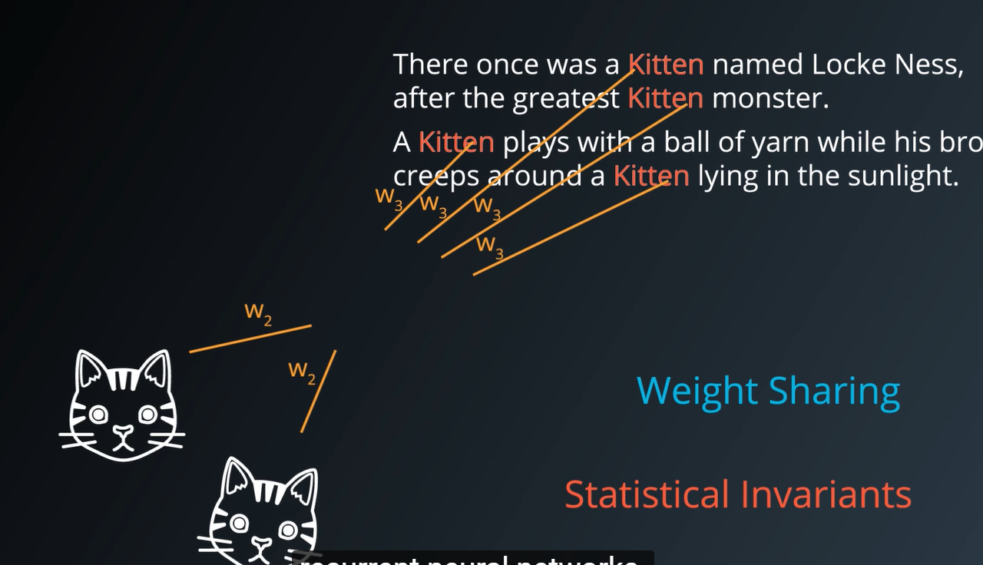

Acest lucru se realizeaza folosind **“Weight Sharing”.** (atunci cand stii ca 2 inputs pot sa contine acelasi tip de informatie, atunci le faci share la weights si le trainuiesti impreuna, pentru acele inputuri).

**Statistical Invariants** = lucruri care nu se schimba in medie in decursul timpului, spatiu, sau oriunde in alta parte.

Pentru imagini, idea de a studia weight sharing, ne va conduce in studierea retelelor neuronale convolutionale. Pentru text, sau secvente in general, ne va conduce la **“embeddings and recurrent neural networks”.**

**Convolutional Networks (CovNets)**

**COVNETS** = neural networks that share their parameters across space.

Link = <https://www.youtube.com/watch?v=ISHGyvsT0QY>

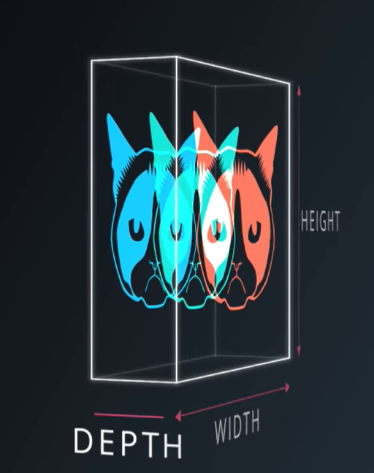

Ai o imagine RGB ce are un (Height, WIDTH, dar si un DEPTH). In cazul acesta DEPTH = 3

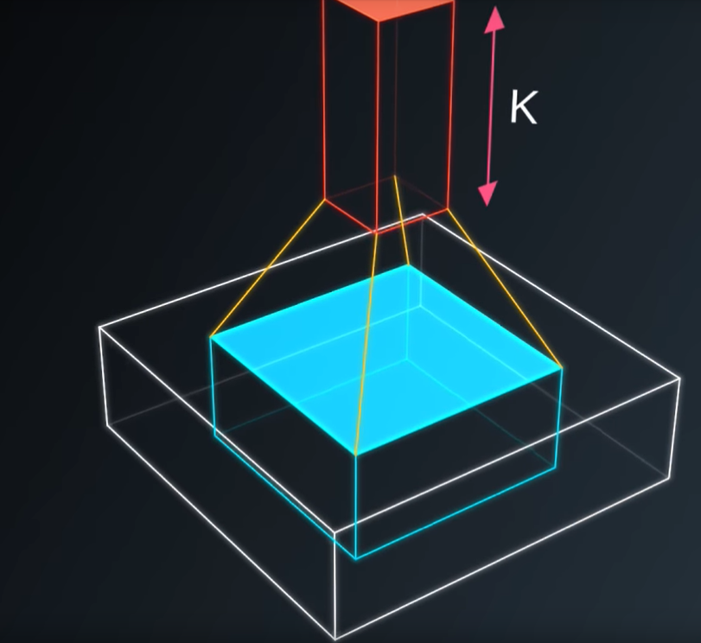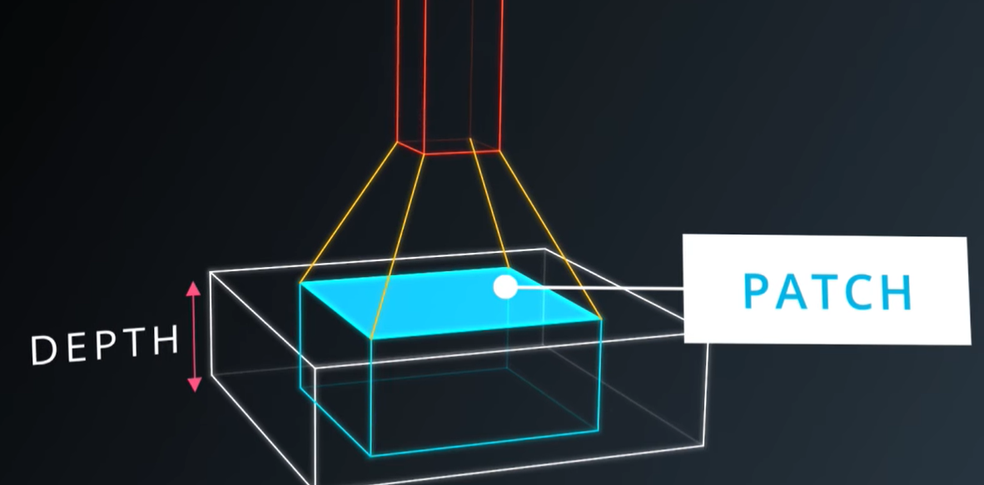

Sa zicem de exemplu, ca asupra imaginii tale iei un mic patch(o portiune din ea) si aplici o retea neuronala asupra ei **(K outputs**).

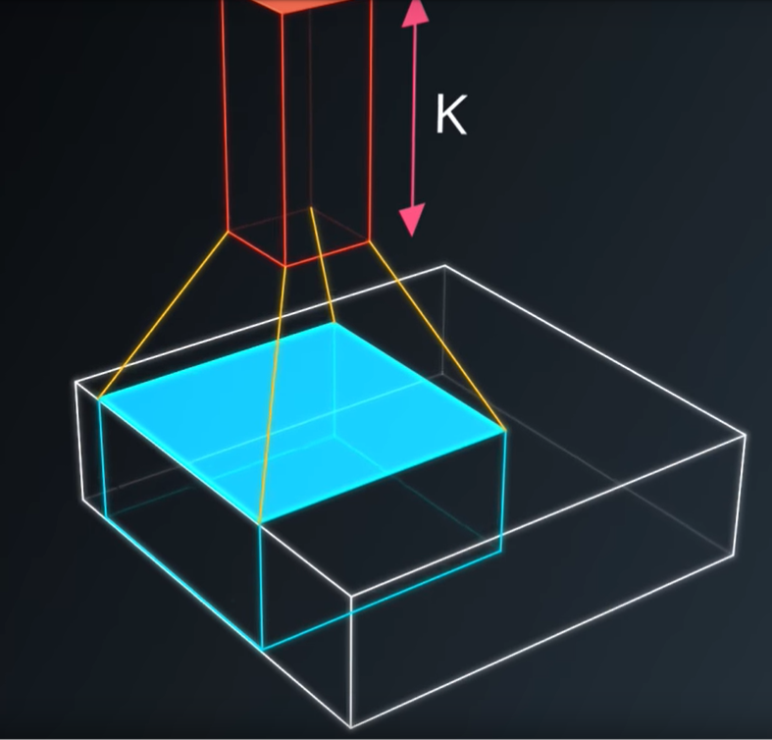

* Apoi iei acea mica retea neuronala, si o aplici cate putin pt fiecare patch ce se poate forma din imaginea ta, **fara sa schimbi weights.**

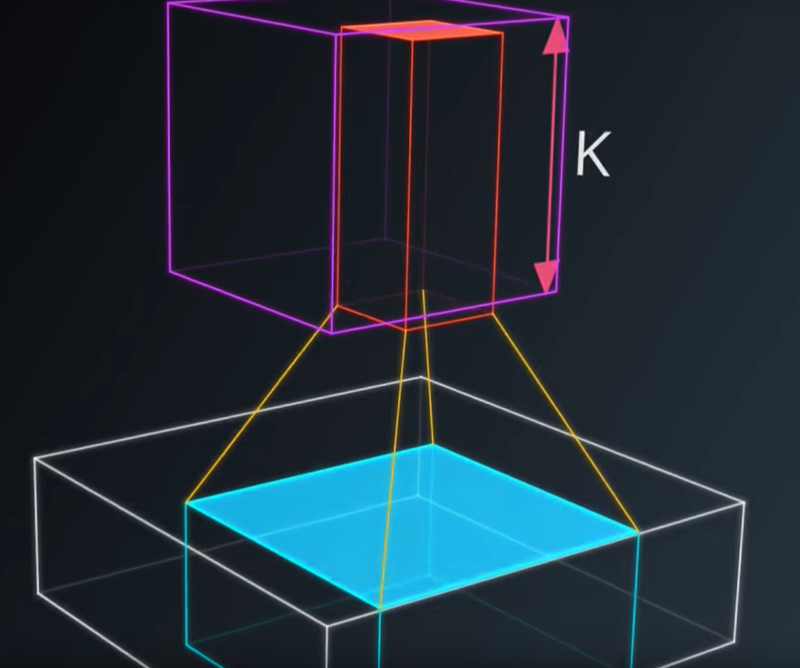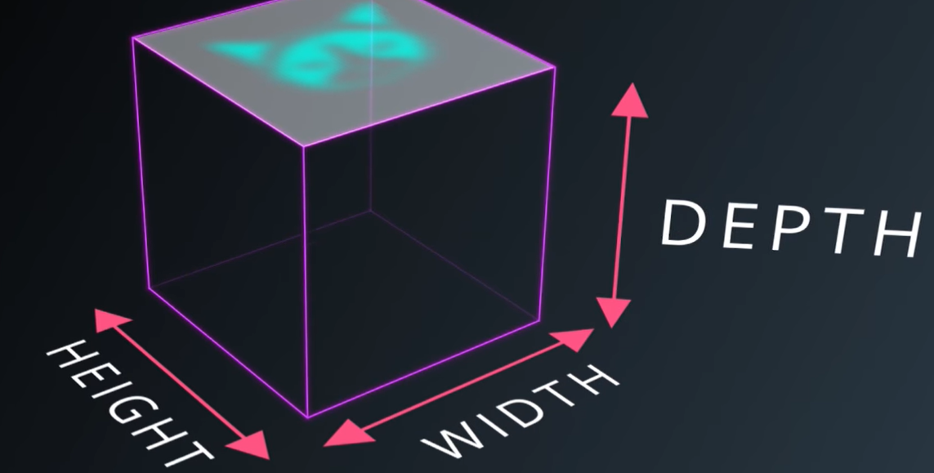

* La Output vom avea o alta imagine, ce va avea un HEIGHT, WIDHT si un DEEPTH diferite(asta e cel mai important).
* In loc de RGB, acum avem un output ce are mai multe canale de culoare, in total K.

ACEASTA OPERATIE SE NUMESTE **CONVOLUTIONS**

* Adica, in loc sa faci patch, asupra intregii imagini, atunci vei face patch doar asupra unui patch mai mic. Astfel, datorita acestui patch mic, vom avea weighturi mai mici ce sunt “shared across space”.

**Covenant** = is an deep network, where instead of having stacks of matrix multiply layers, we’re goiing to have stacks of convolutions.

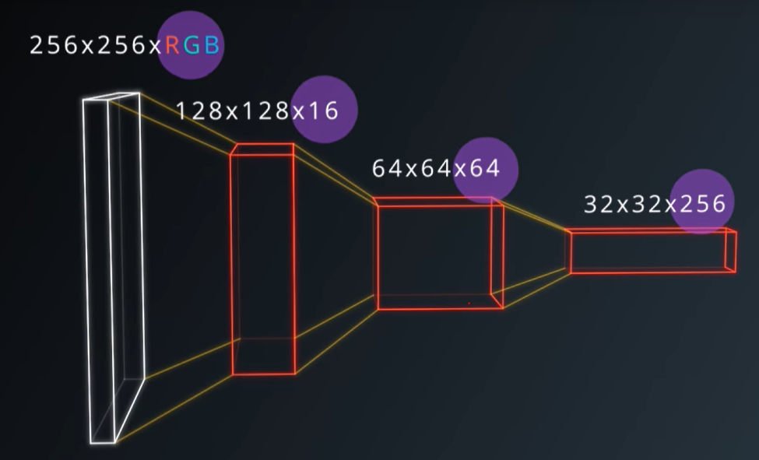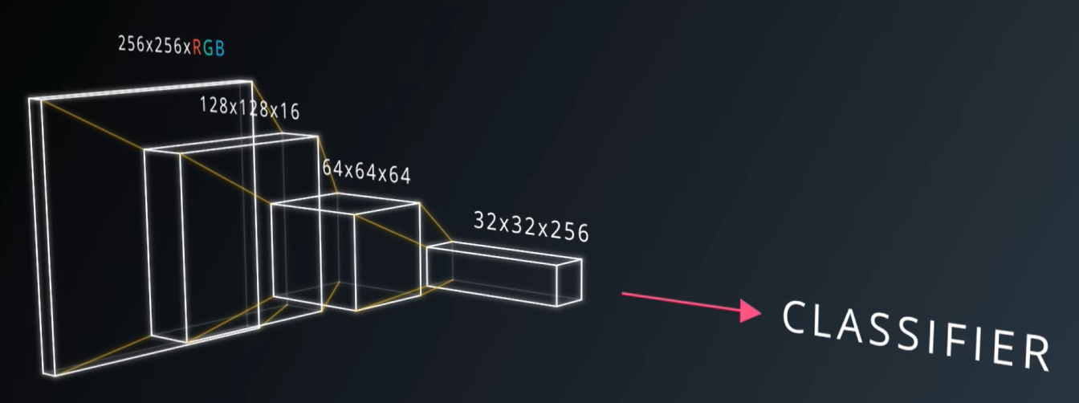

Ideea generala, este ca vor forma o piramida. Unde primul layer, este imaginea mea mare, dar un depth micut RGB. Astfel, voi aplica convolutions, ce va reduce dimensiunile, crescand in acelasi timp DEPTH, ce corespunde reprezentarii semantice a complexitatii mele.

In top voi avea Clasificatorul meu.



**Patch** = se mai numeste si **kernels**

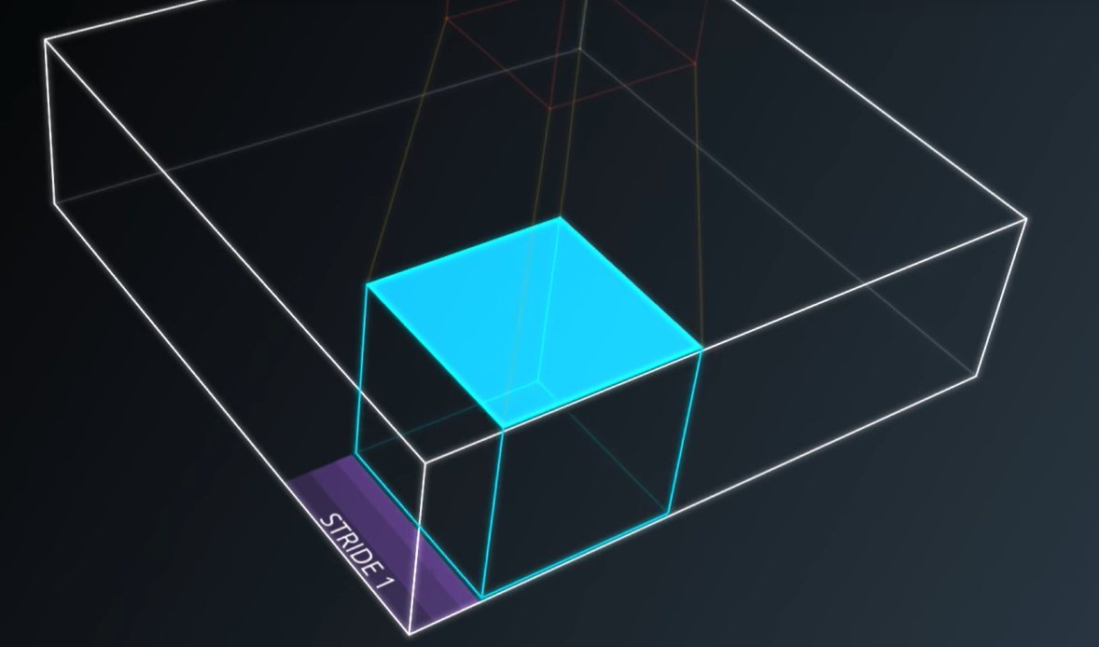

**Stride** = numarul de pixeli care ii shiftezi pentru a muta filterul tau. Stride = 1 (exact dimensiunea imaginii), Stride = 2 (mai mic)

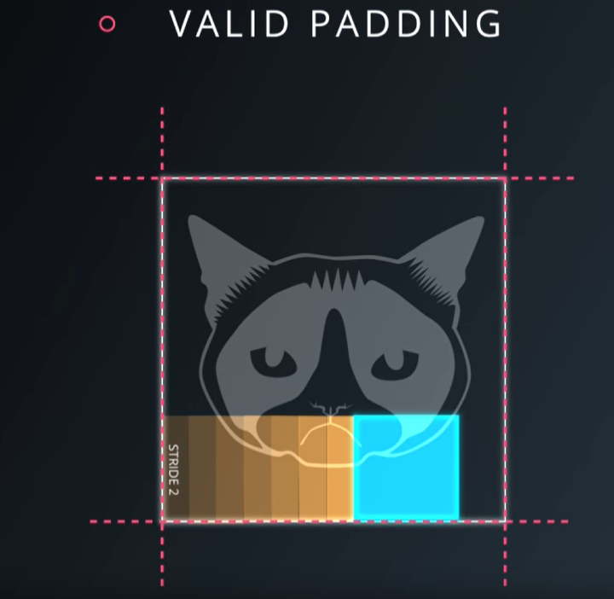

**Valid Padding** = folosesti un stride, ce se incadreaza perfect in imagine.

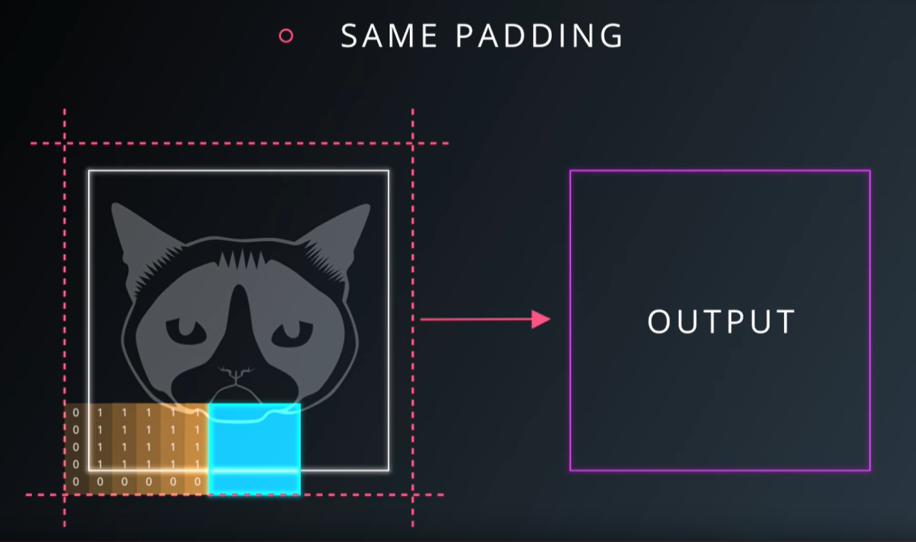

**Same Padding** = depasesti imaginea, si egalezi edgeurile cu 0. In schimb, dimensiunea imaginii ramane aceiasi.

**Intuition**

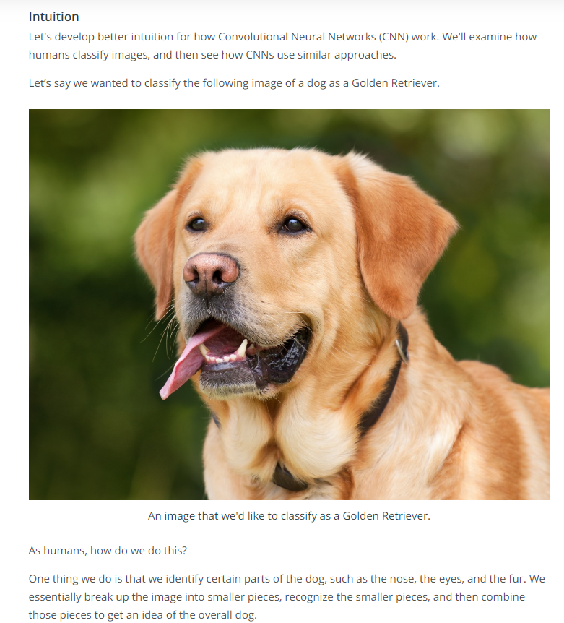

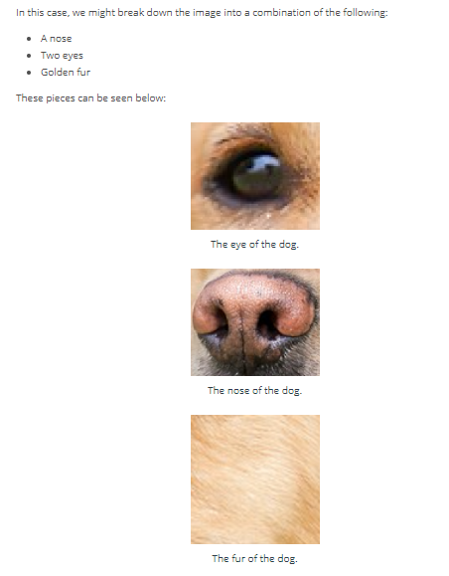

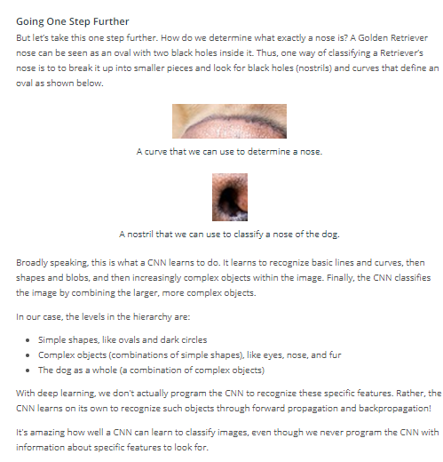

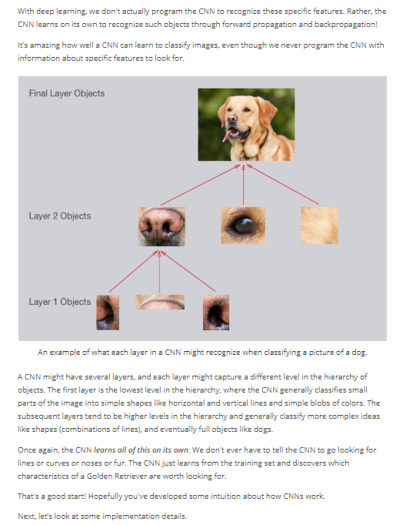

**Filters**

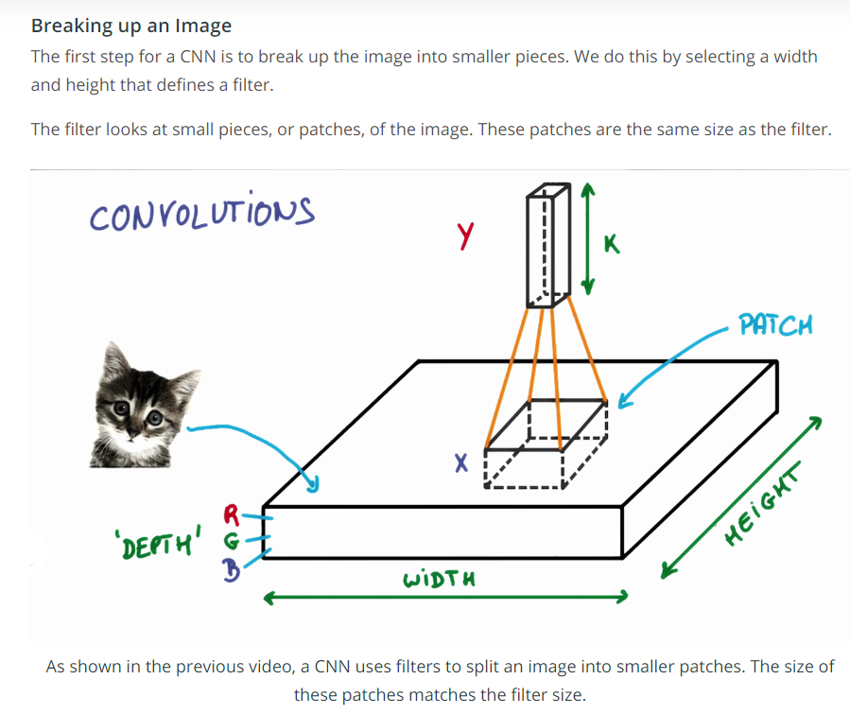

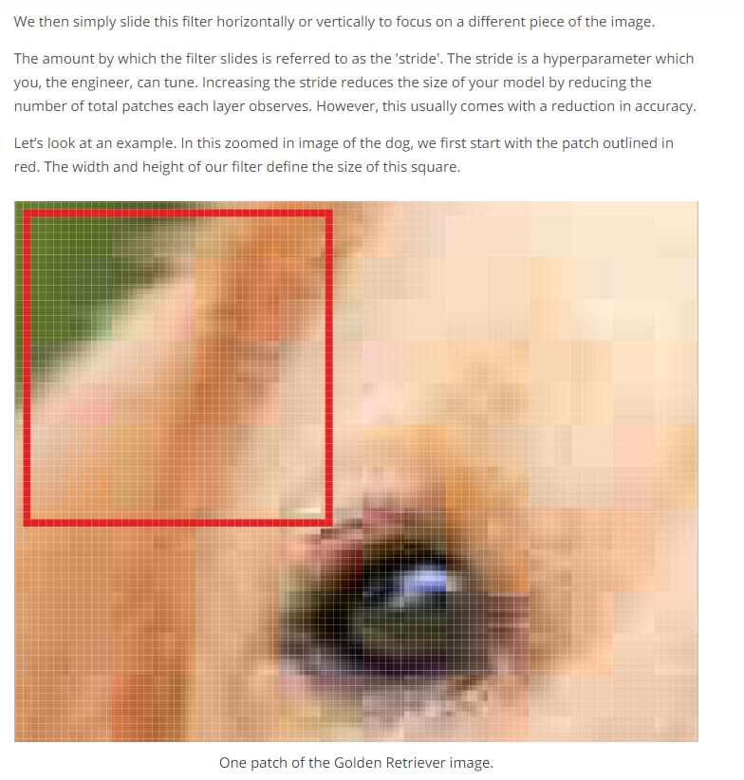

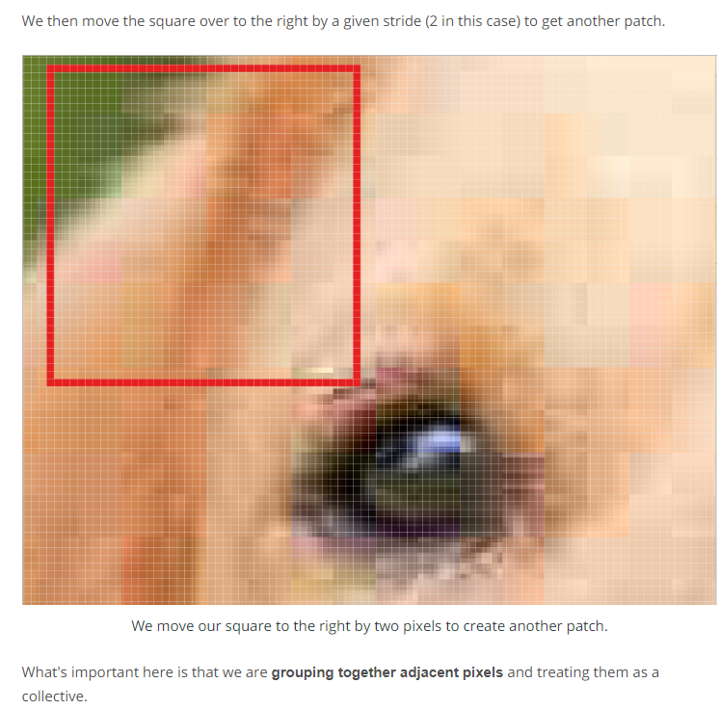

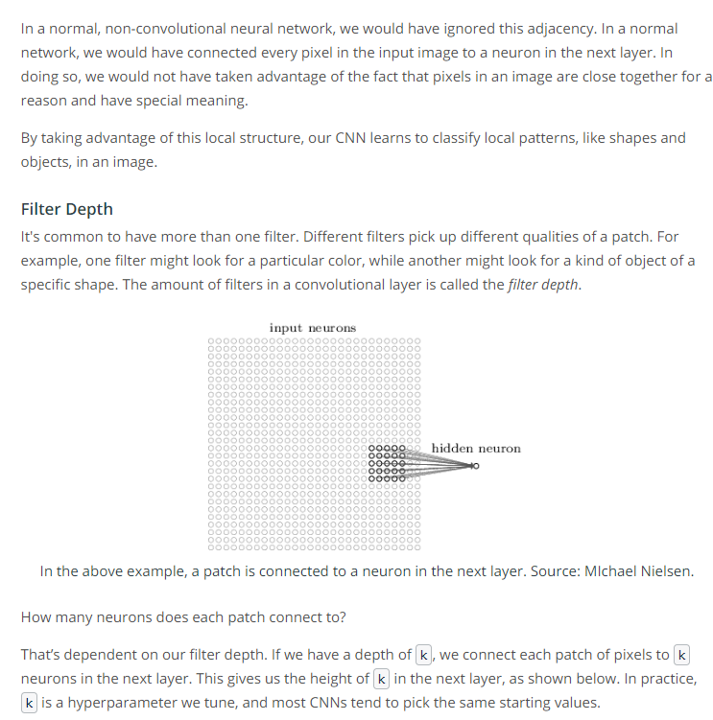

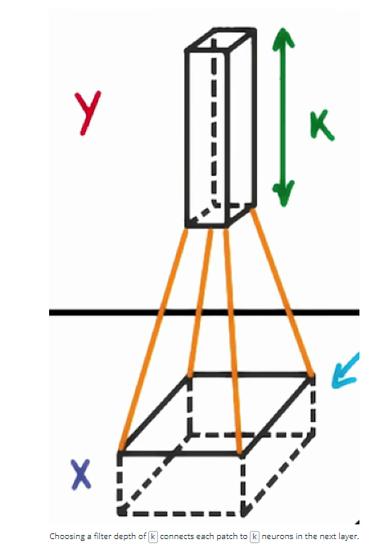

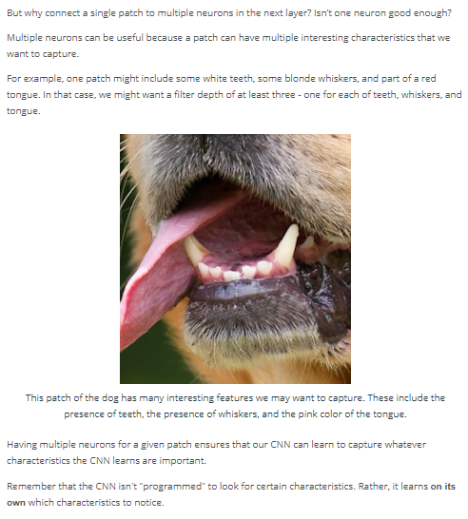

**Feature Map Sizes**

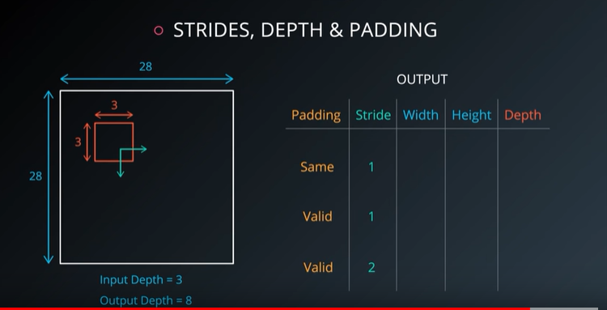

Link Video: <https://www.youtube.com/watch?v=lp1NrLZnCUM>

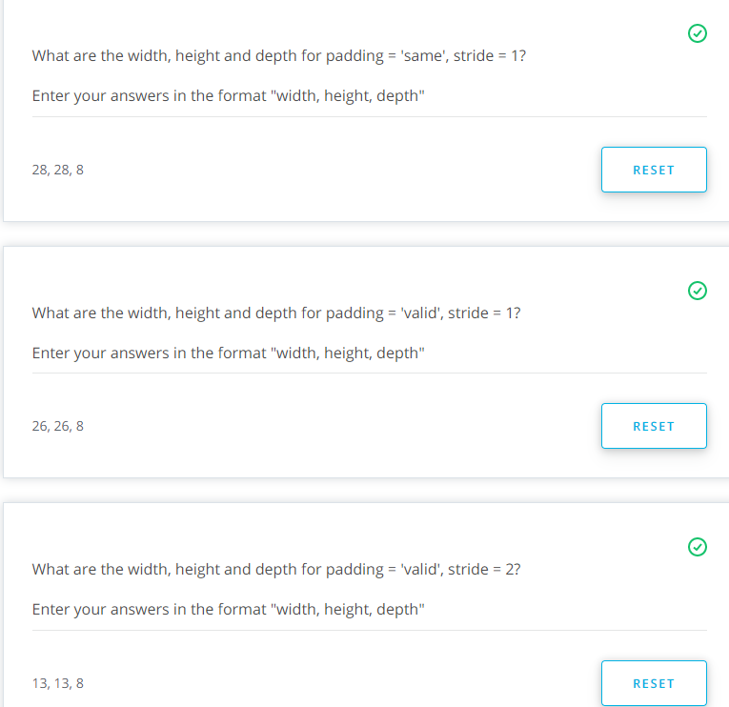

Explicatie in video: <https://www.youtube.com/watch?v=W4xtf8LTz1c>

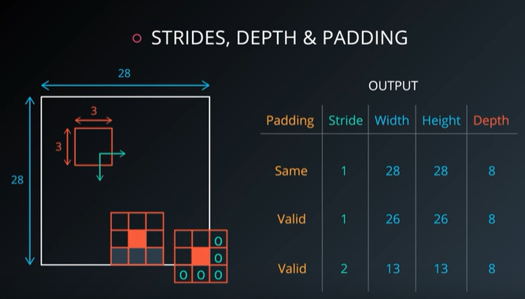

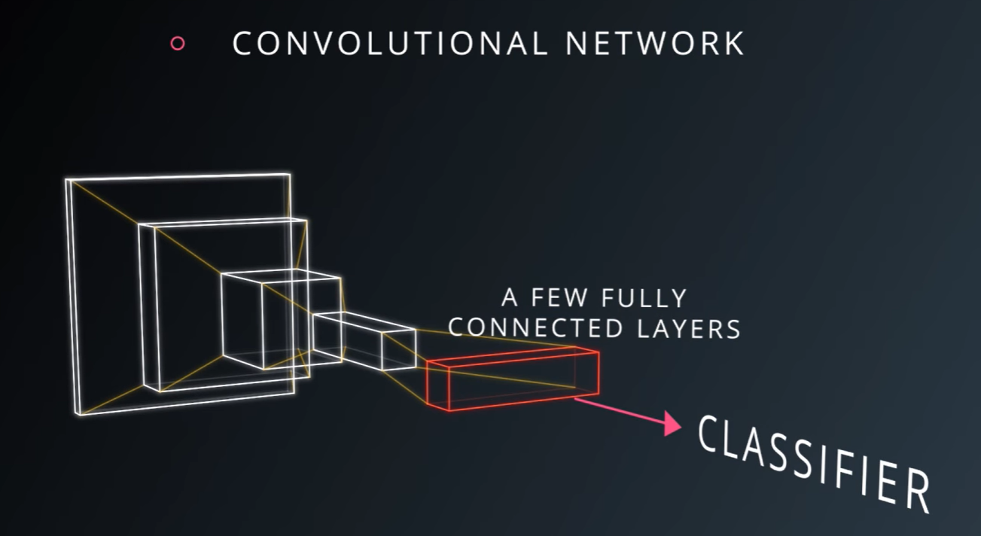

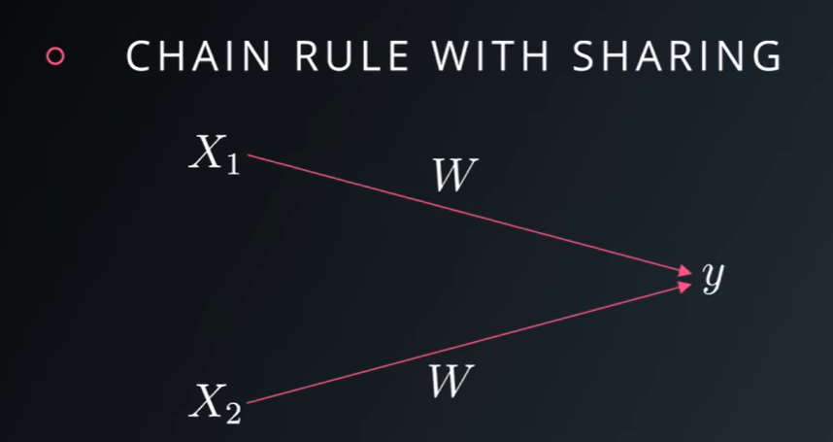

Ce se intampla atunci cand ai Weighturi la fel, in cazul de sharing?

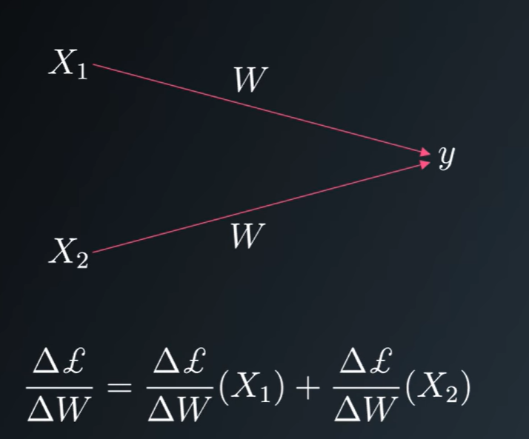

Raspuns: Nimic, trb sa calculezi derivatele, pt toate posibilele locatii din imagine

Link video: <https://www.youtube.com/watch?v=utOv-BKI_vo>

**Parameter Sharing**

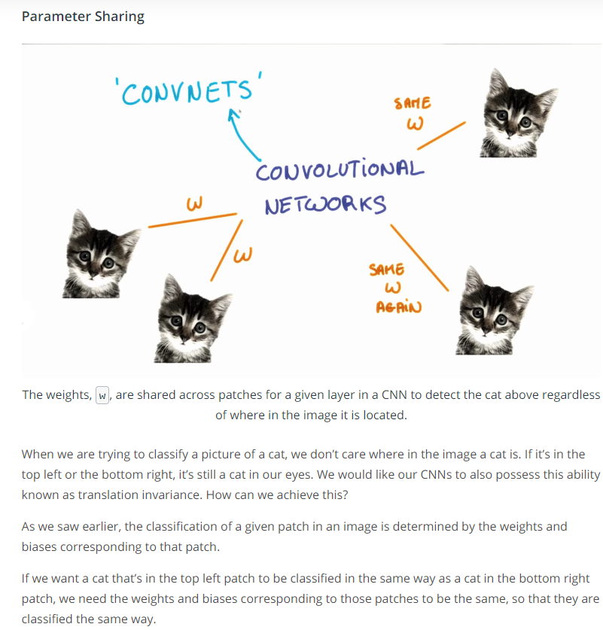

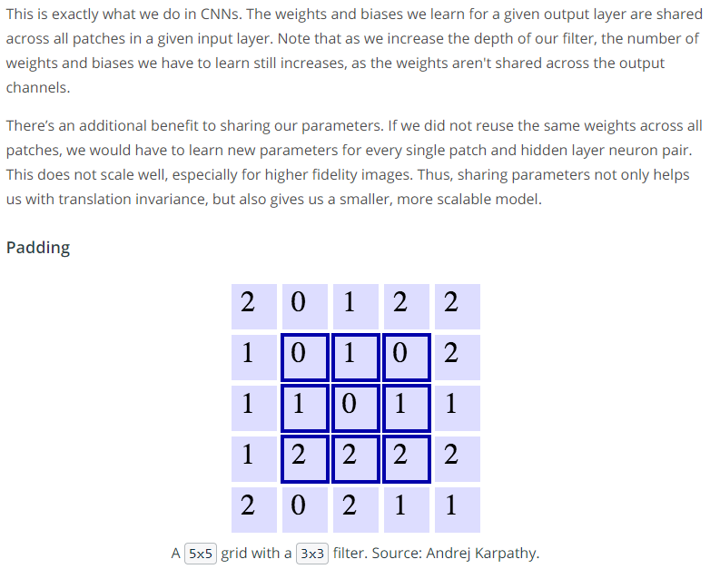

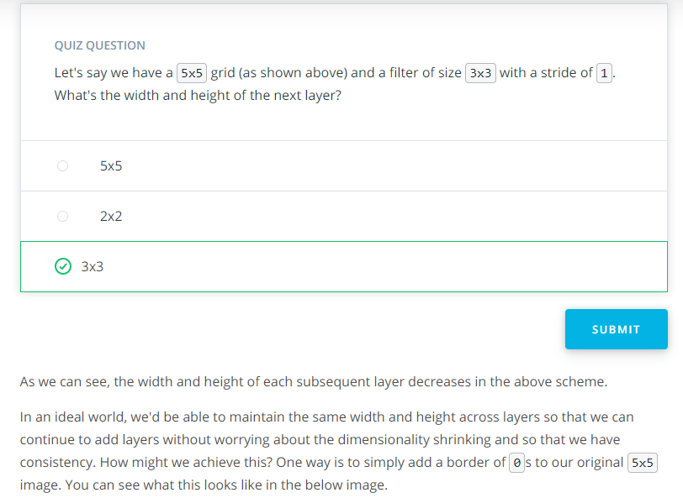

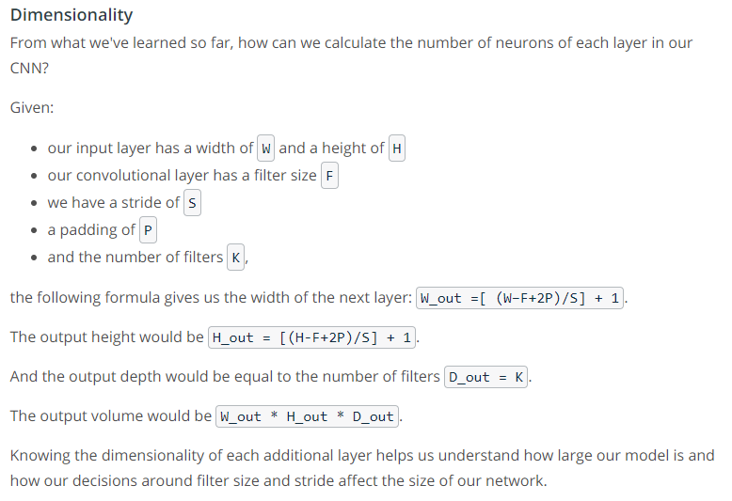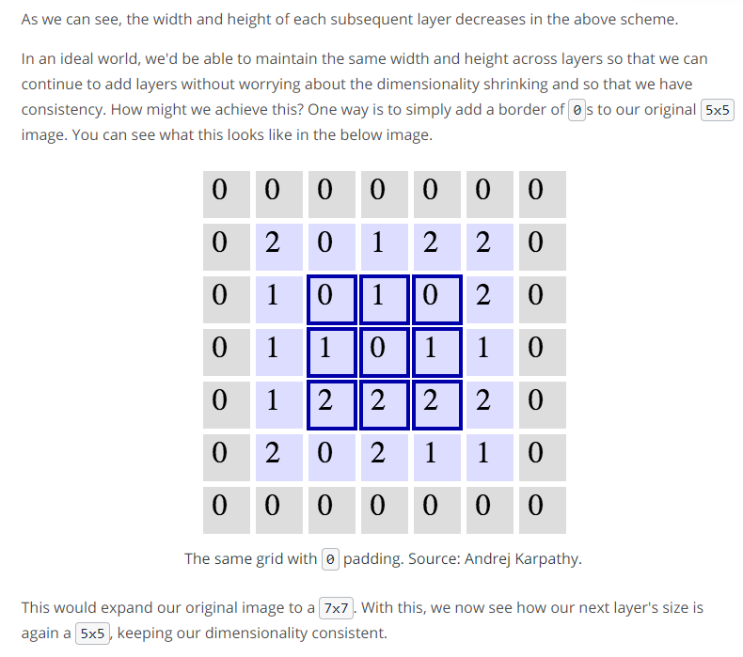

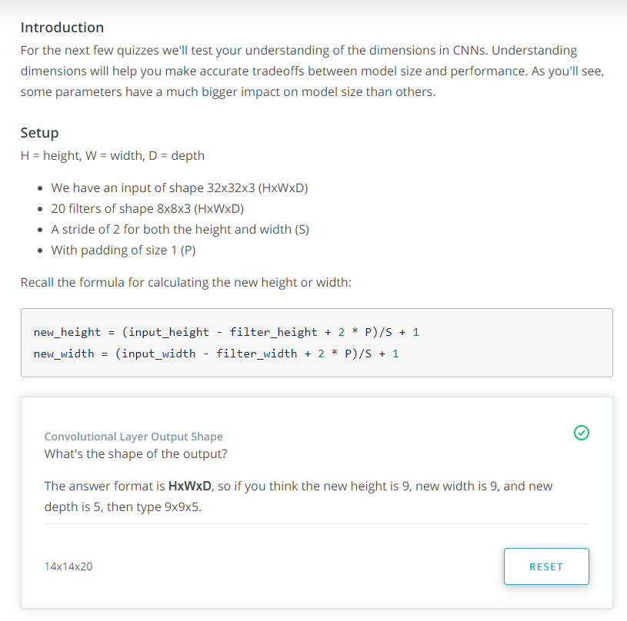

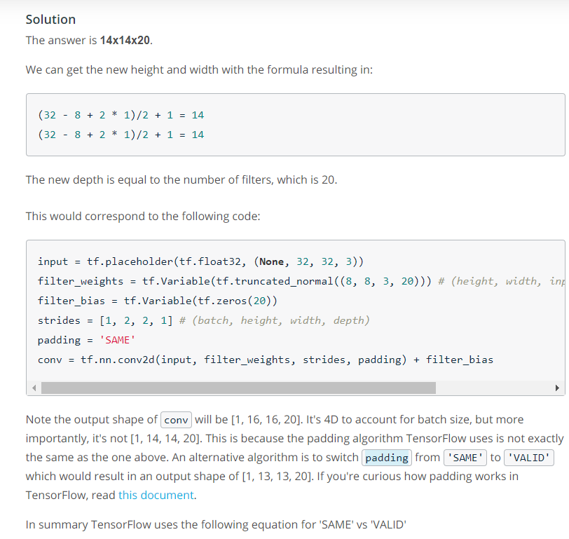

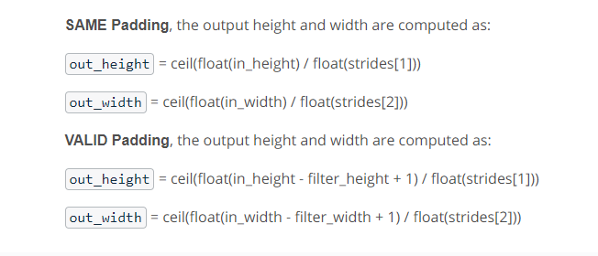

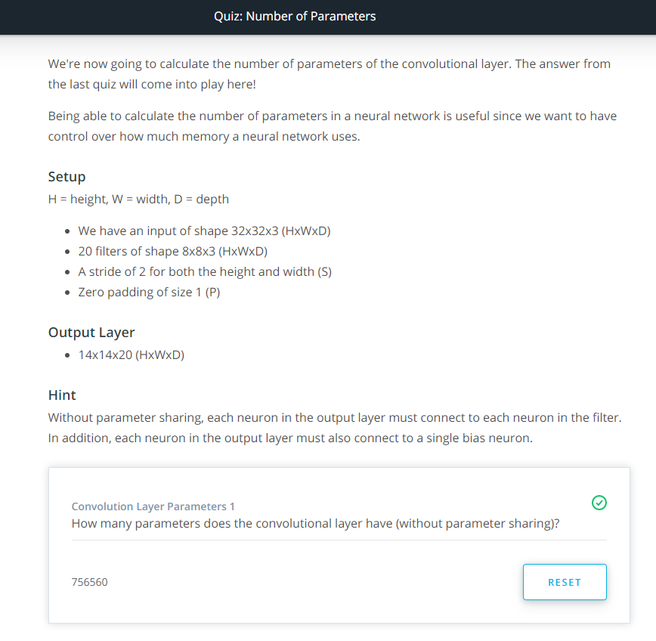

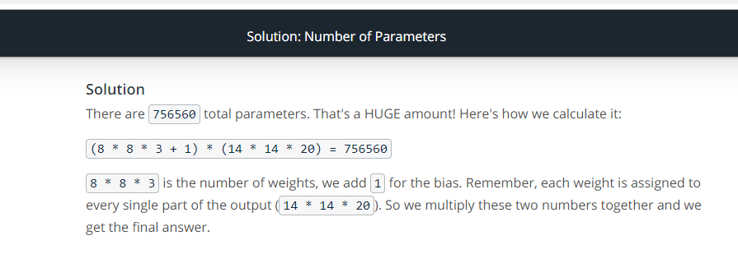

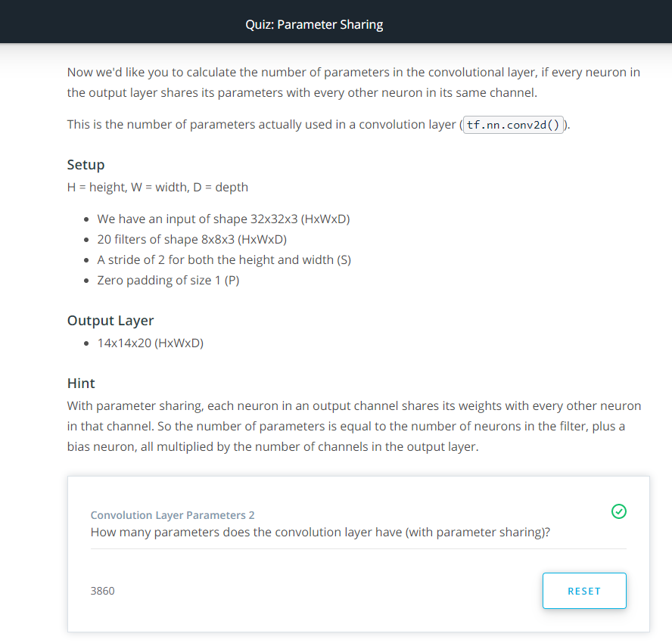

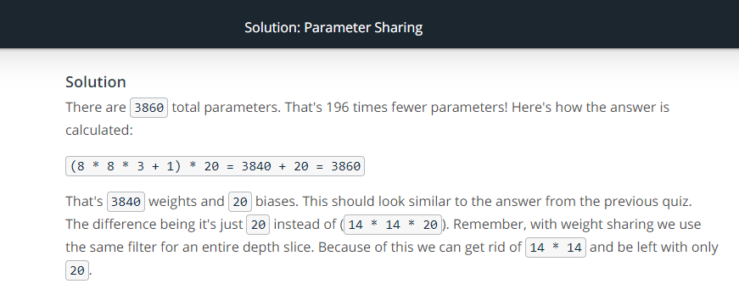

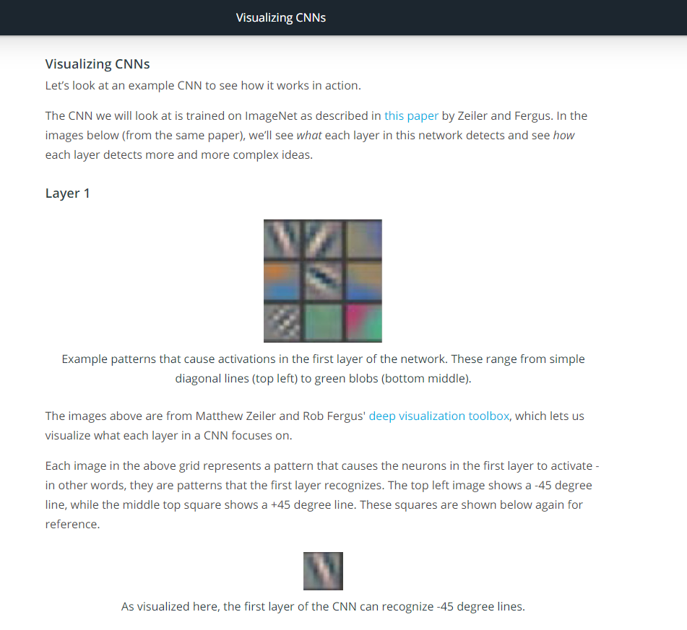

Link1: <https://arxiv.org/abs/1311.2901>

Link2: <https://www.youtube.com/watch?v=ghEmQSxT6tw>

Alt link: <https://www.3blue1brown.com/neural-networks>

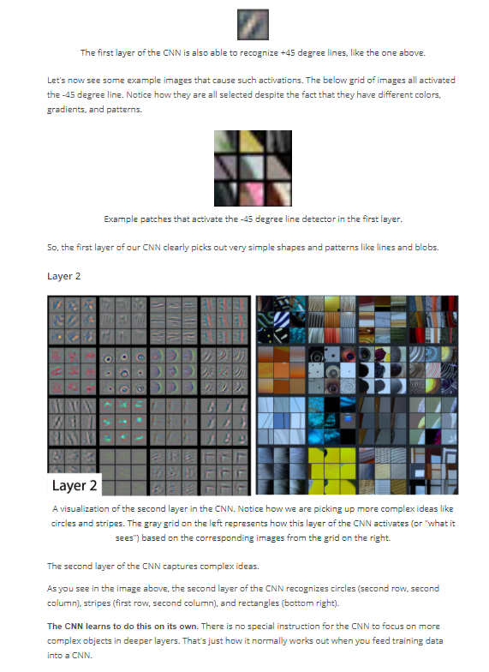

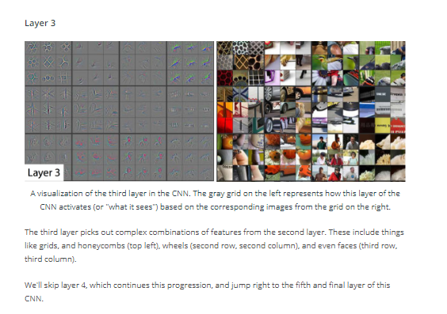

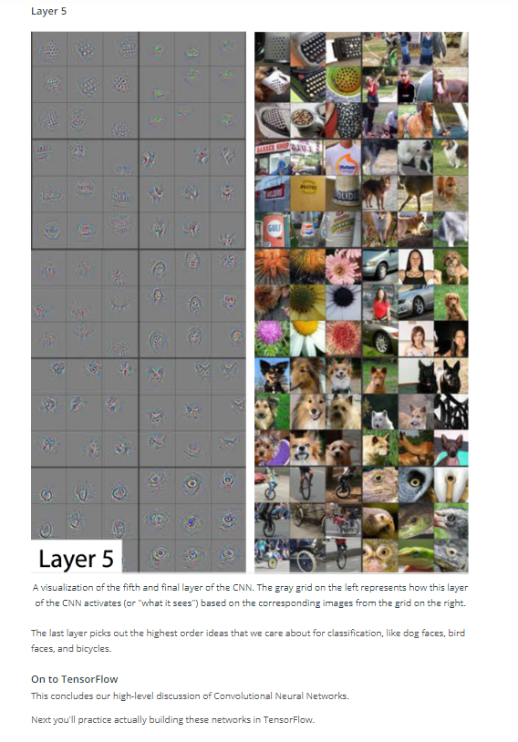

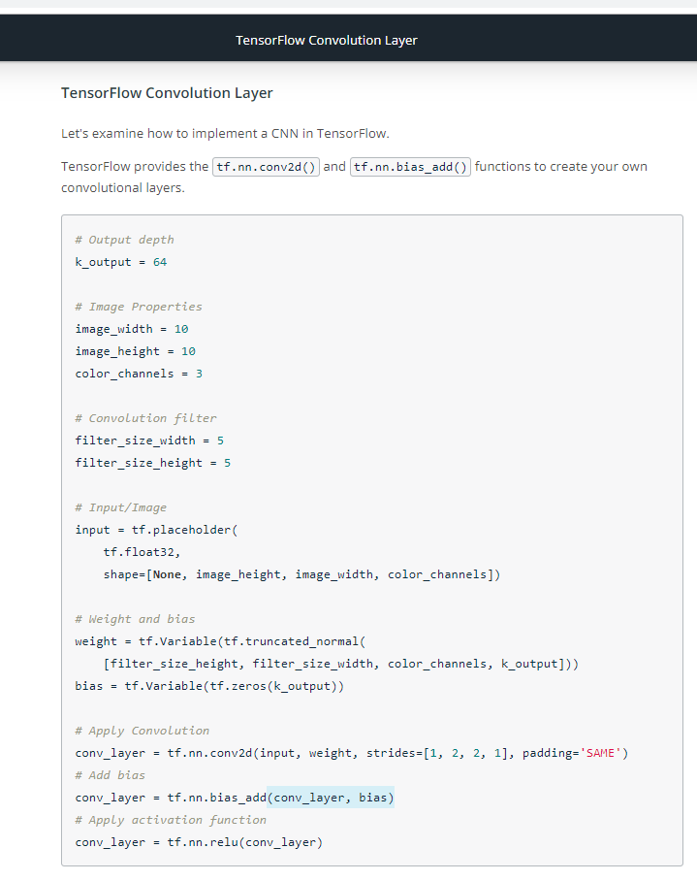

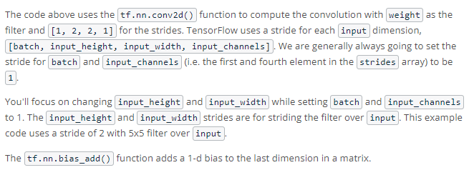

**Explore Design Space**

Acum vom discuta niste improvementuri, la ce putem sa facem.

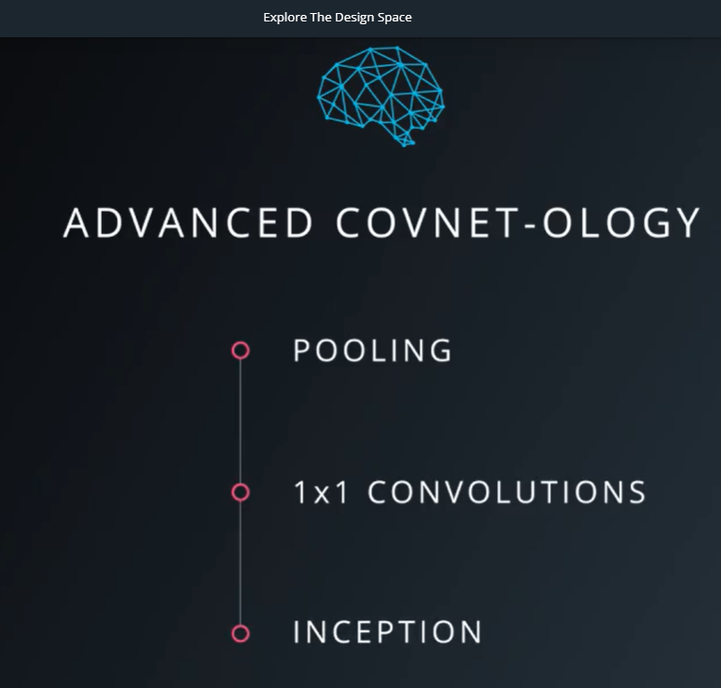

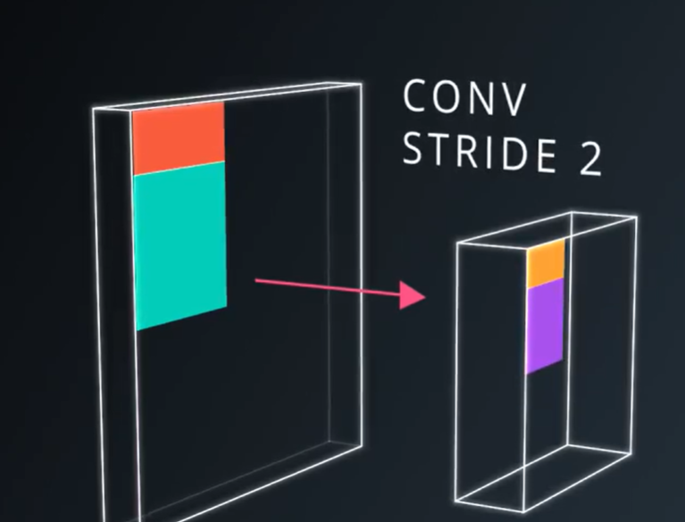

The first improvement is a better way to reduce the spatial extent of your future maps in the convolutional pyramid. Until now, we used striding to shift the filters by a fiew pixels each time, and reduce the feature map size.

This is a very aggressive way to down sample an image. It removes a lot of information.

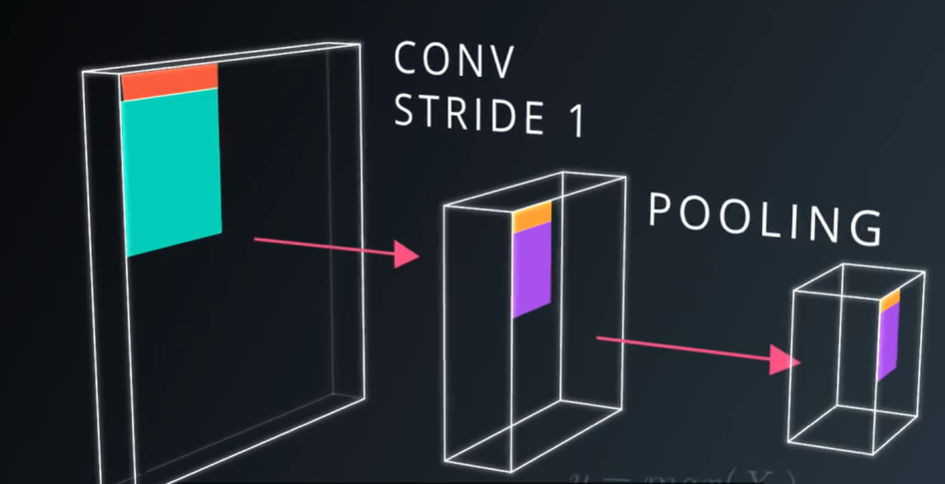

What if instead of skipping one in every two convolutions, we still run with a very small stride, say for example, 1 but then took all the convolutions in a neighborhood and combine them somehow?

This operation is called **POOLING**, and there are a fiew ways to go about it.

The most common is the **MAX POOLING**. At ebery point of on the feature map, look at a small neighborhood around that point, and compute the maximum of all the responses around it.

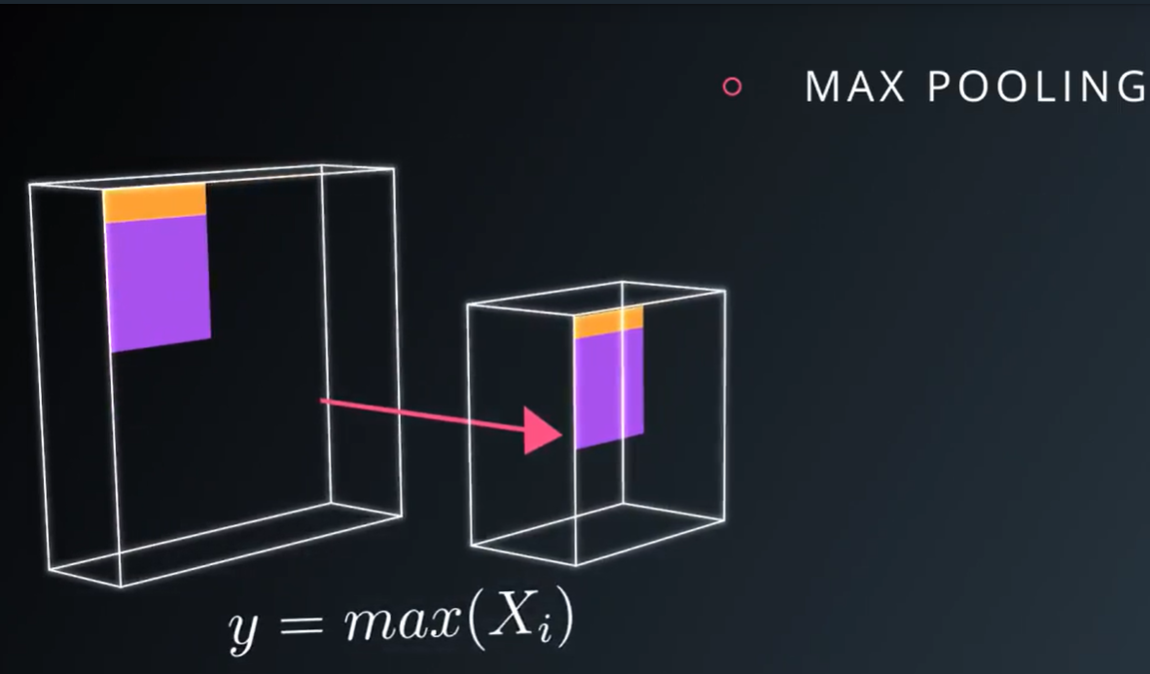

There are some advantages to using **max pooling**.

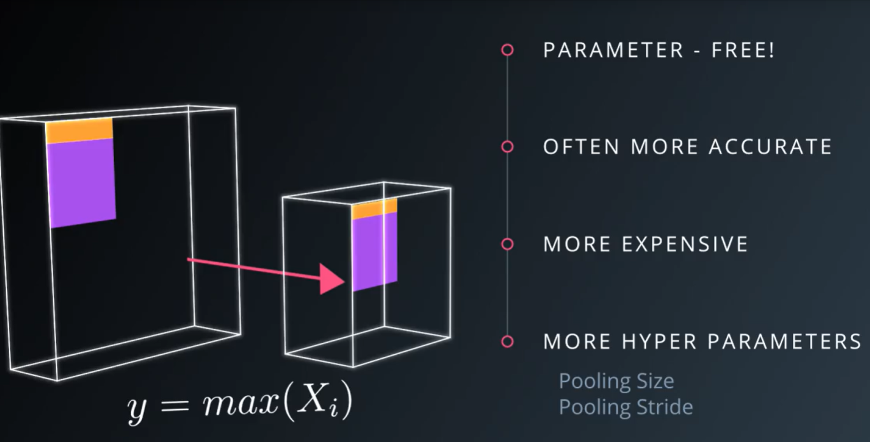

1. It does not add your number of parameters, so you don’t risk an increase in overFitting.
2. It simply often yields a more accurate model. However, since the convolutions that went below run at lower stride, the muddle then becomes a lot more expensive to compute. And now, you have even more hyper-parameters to worry about: Pooling region side, and pooling stride. And NO, they don’t need to be the same

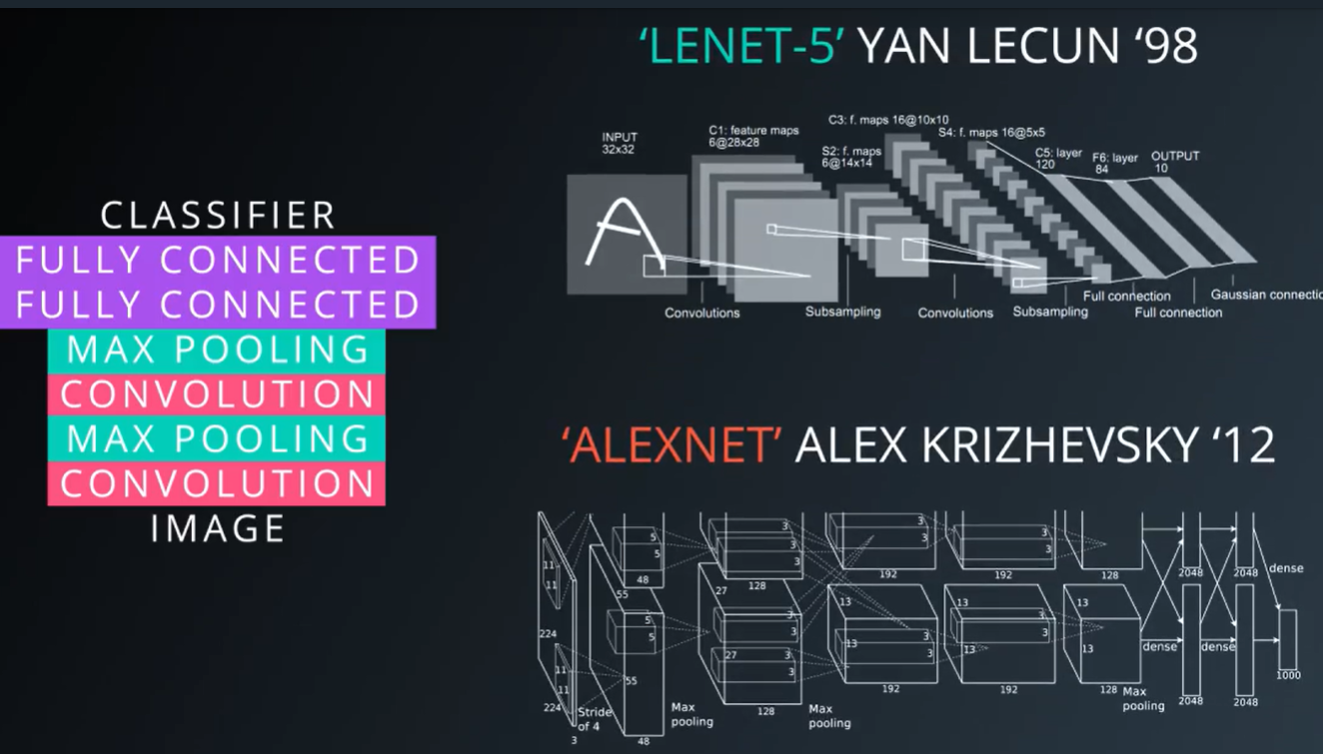

A typical architecture for a covnet is a few layers alternating convolutions, and MAX POOLING, by a fully connected layers at the top.

The first famous model to use this architecture was **Lenet-5**, designed by Yan Lecun to do character recogniztion back in 1998.

Modern convolutional networks, such as AlexNet, which famously won the competitive ImagNnet object recognition challenge in 2012, used the same architecture with a few wrinkes.

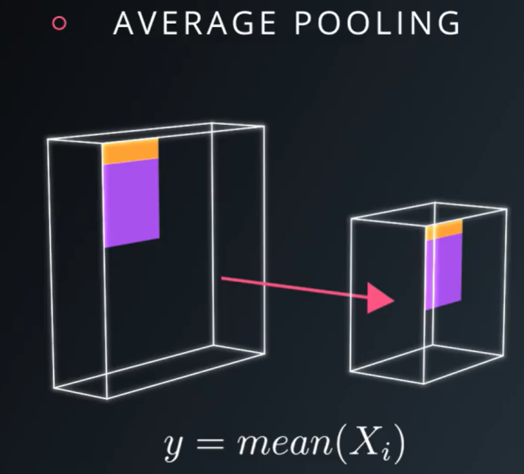

Another form of pooling, is **average pooling**. Instead of taking the max, just take an average over the window of pixels around a specific location. It’s a little bit like providing a blurred low resolution view of the feature map below.

**Tensorflow Max Pooling**

Link Max Pooling: <https://en.wikipedia.org/wiki/Convolutional_neural_network#Pooling_layer>

**MAX POOLING:**  It [partitions](https://en.wikipedia.org/wiki/Partition_of_a_set) the input image into a set of non-overlapping rectangles and, for each such sub-region, outputs the maximum.

This is the idea behind the use of pooling in convolutional neural networks. The pooling layer serves to progressively reduce the spatial size of the representation, to reduce the number of parameters, [memory footprint](https://en.wikipedia.org/wiki/Memory_footprint) and amount of computation in the network, and hence to also control [overfitting](https://en.wikipedia.org/wiki/Overfitting). It is common to periodically insert a pooling layer between successive convolutional layers in a CNN architecture.

The pooling layer operates independently on every depth slice of the input and resizes it spatially. The most common form is a pooling layer with filters of size 2×2 applied with a stride of 2 downsamples at every depth slice in the input by 2 along both width and height, discarding 75% of the activations. In this case, every [max operation](https://en.wikipedia.org/wiki/Maximum) is over 4 numbers. The depth dimension remains unchanged.

In addition to max pooling, pooling units can use other functions, such as [average](https://en.wikipedia.org/wiki/Average) pooling or [ℓ2-norm](https://en.wikipedia.org/wiki/Euclidean_norm) pooling. Average pooling was often used historically but has recently fallen out of favor compared to max pooling, which performs better in practice.

O alte explicatie pe yb: <https://www.youtube.com/watch?v=ZjM_XQa5s6s>

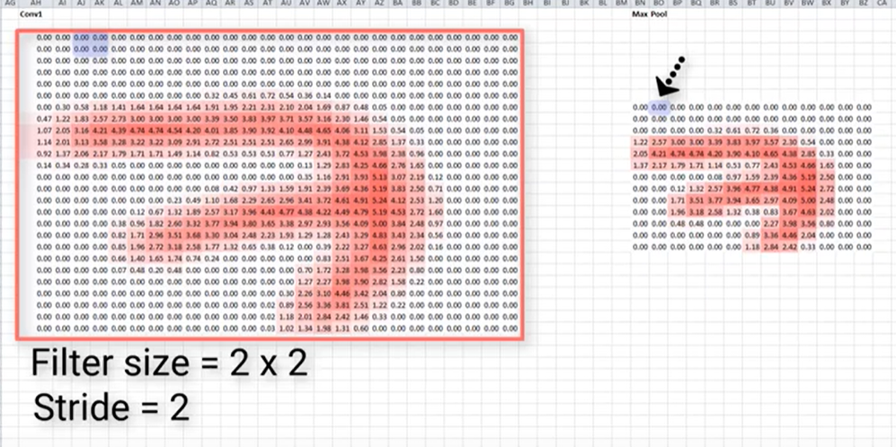

**Deci, cand este adaugat asupra unui model, acesta reduce dimensiunea imaginii, prin reducerea numarului de pixeli din outputul layer-ului convolutional anterior.**

* de exemplu, alegi un filtru de 2x2 si un stride de 2, adica cati pixeli sa muti tu filterul.
* Apoi din fiecare regiune, alegi valoarea maxima si o salvezi in noua ta matrice.
* Ne putem gandi la toate aceste regiuni, ca pools of numbers, si de la asta vine si numele de max pooling.

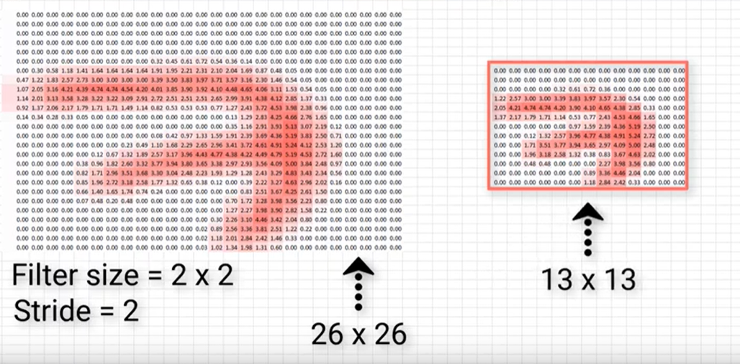

* Dupa aplicarea max pooling se observa ca s-a redus imaginea.

Un alt exemplu ca sa vezi mai bine:

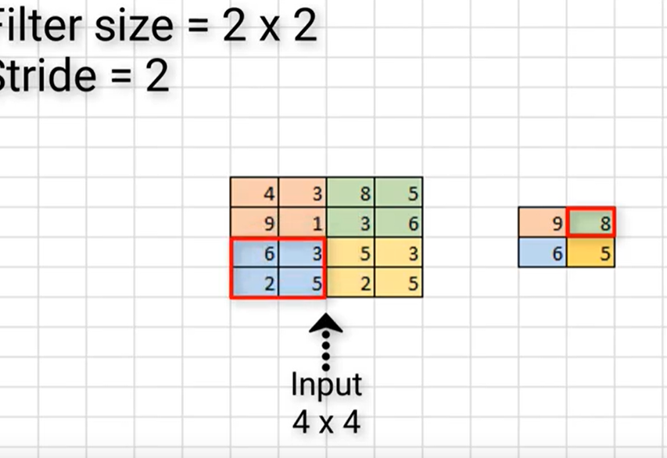

La ce ajuta, pe langa ca reduce dimensiunea imaginii?

* Reduce parameters and computation load, la reteaua noastra.
* Reduce overfitting.
* Sa extraga particular features.

Average Pooling = tot un fel de max pooling, doar ca face media.

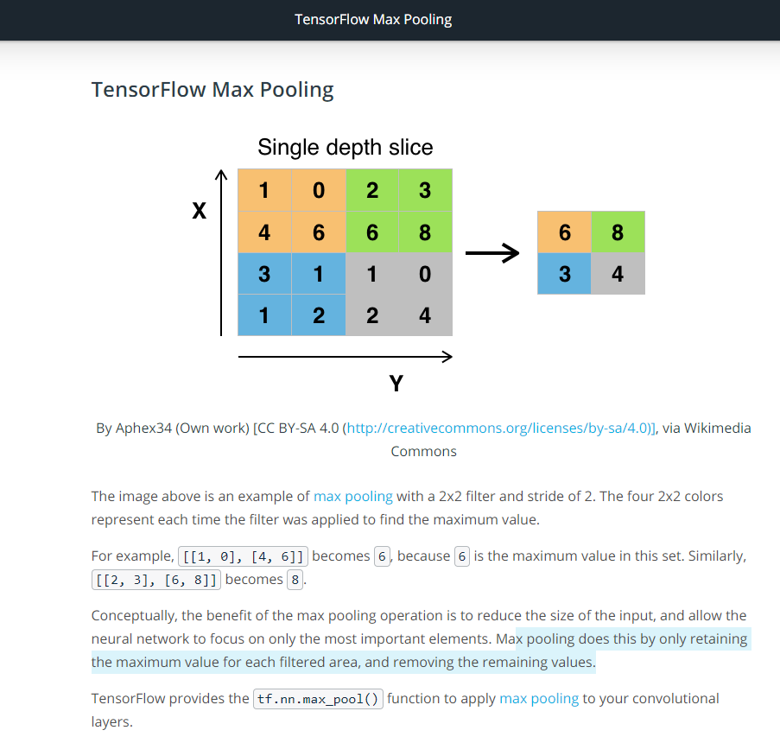

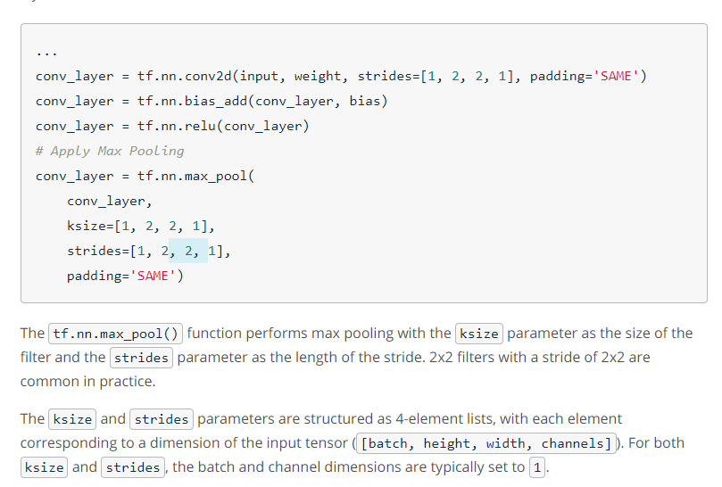

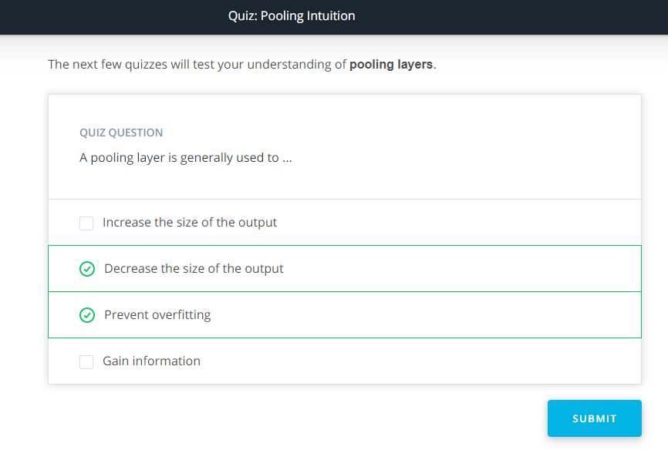

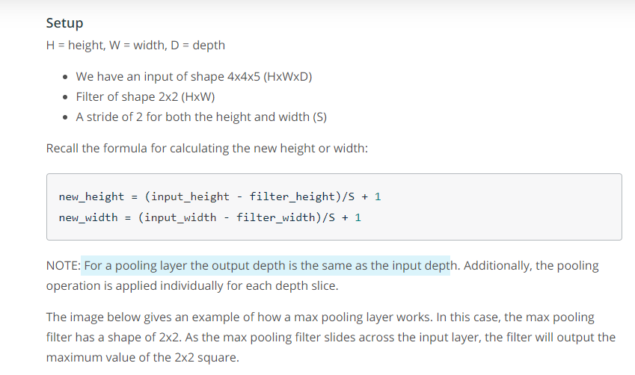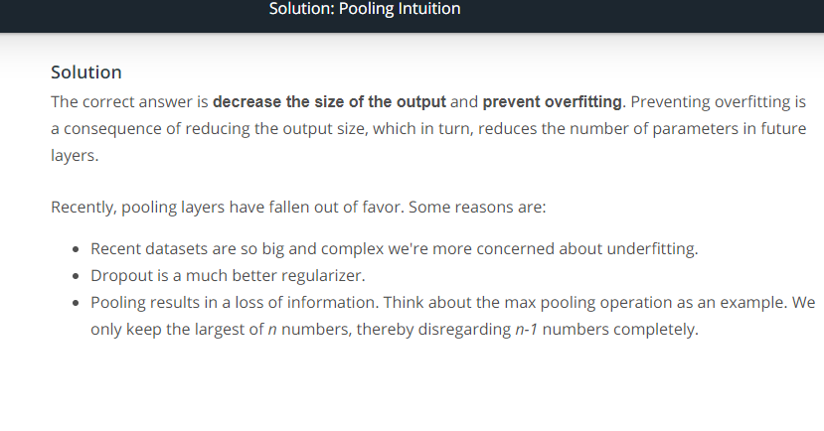

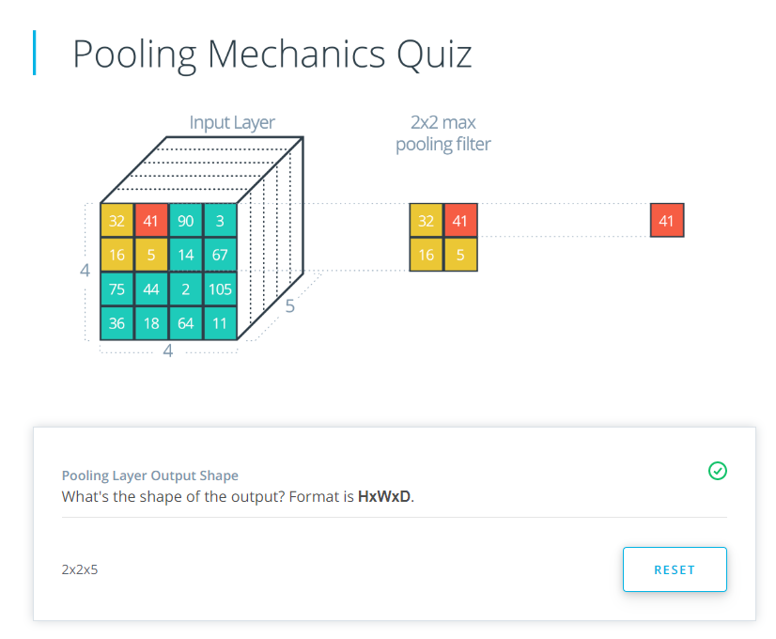

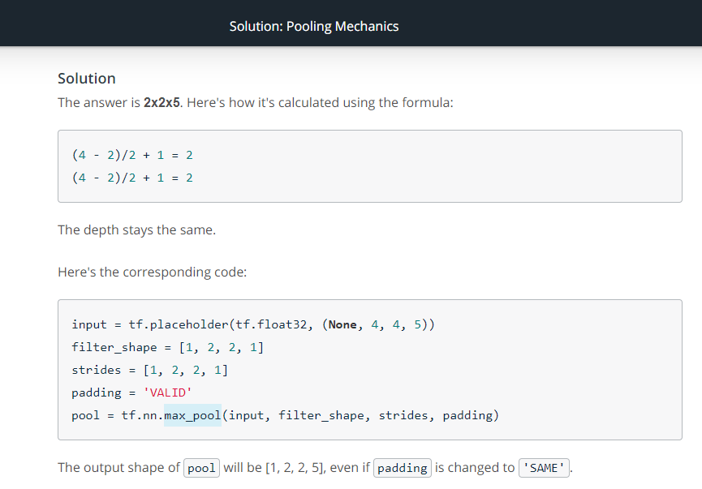

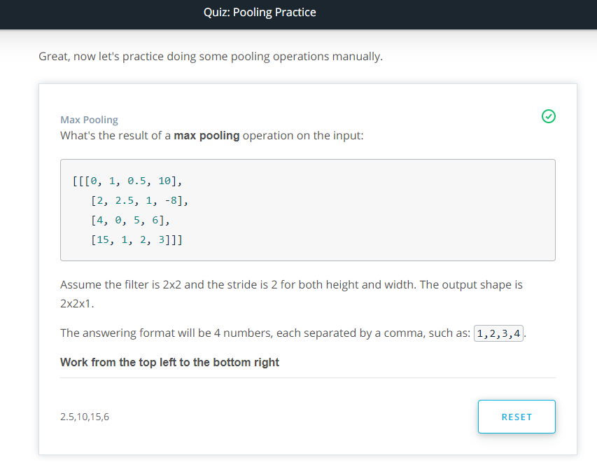

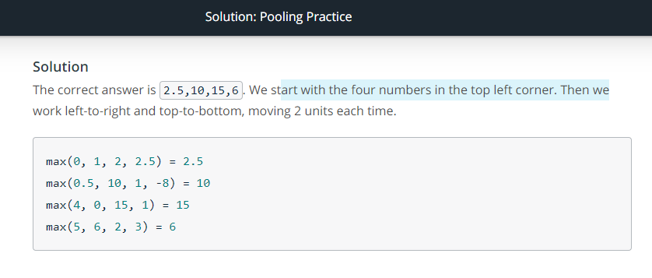

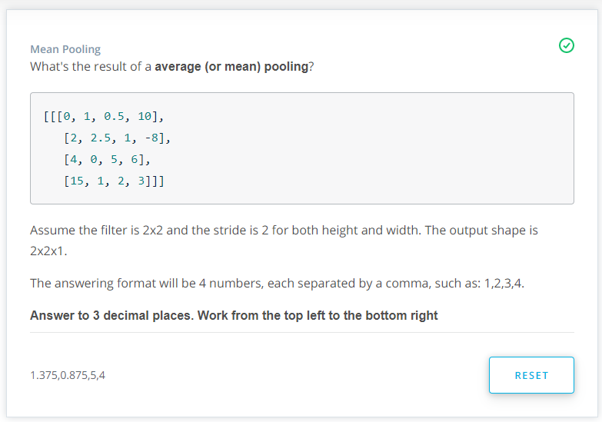

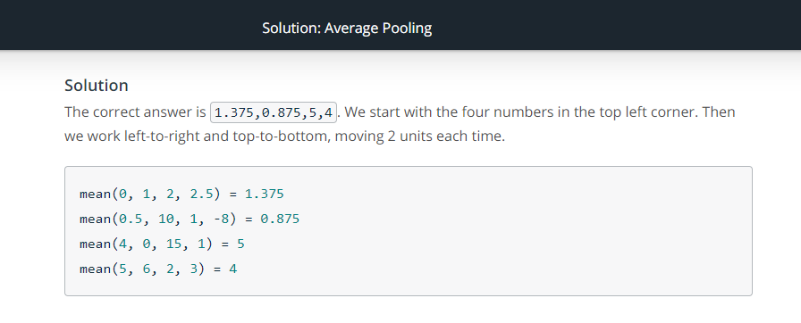

**1x1 Convolutions**

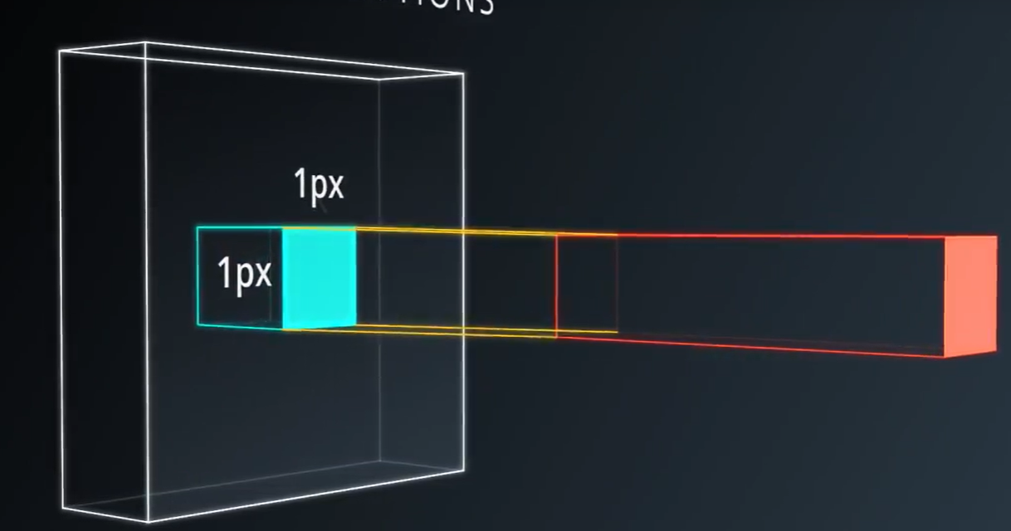

Why would ever want to use 1x1 convolutions? They’re not really looking at a patch of the image just that one pixel.

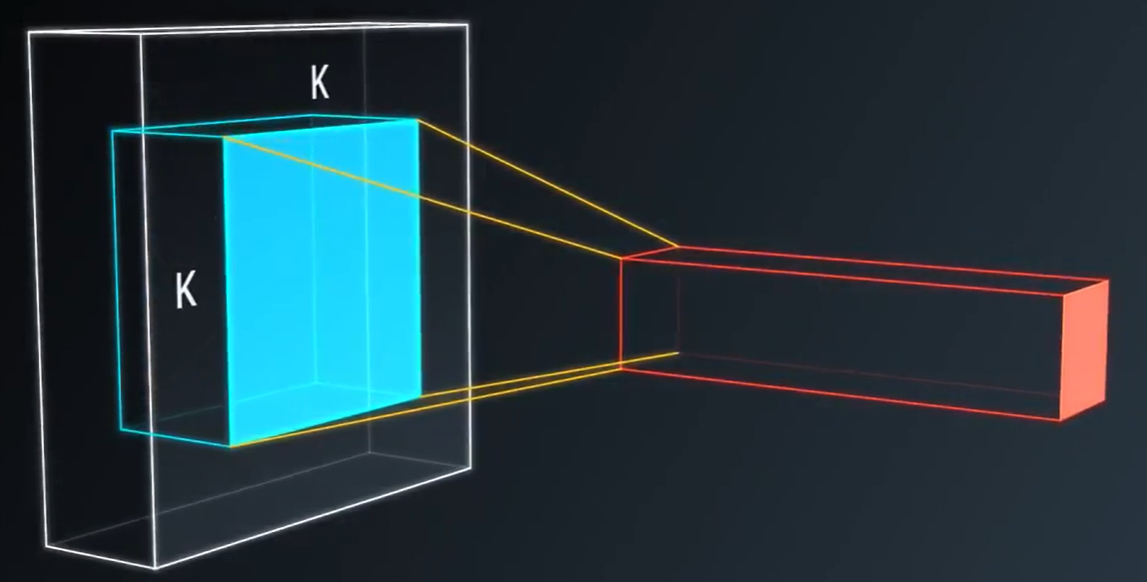

For example, the classic convolution setting, it’s basically a small classifier for a patch of the image, but it’s only a liniar classifier.

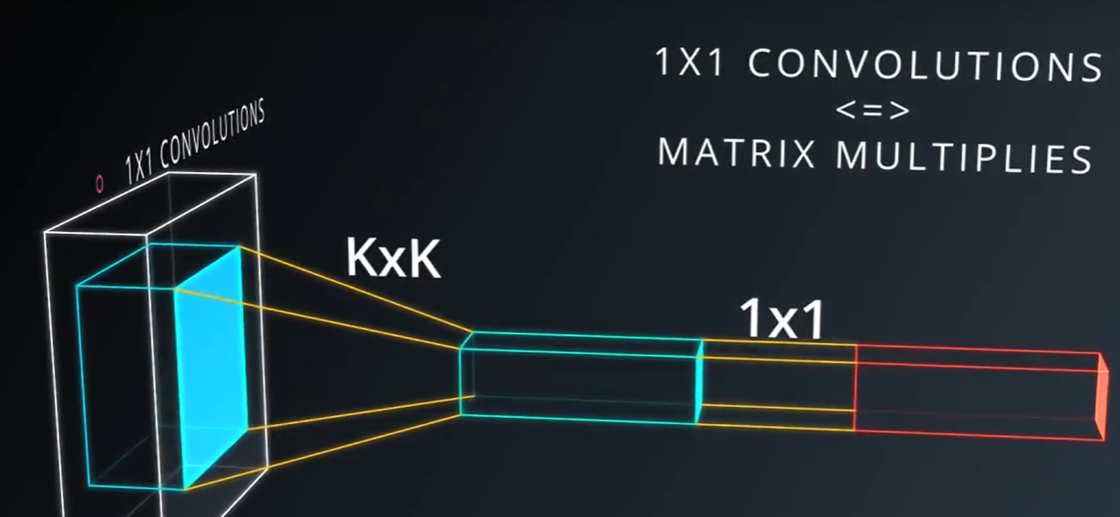

But if you add 1x1 convolution in the middle, suddenly you have a mini neural network running over the patch instead of a liniar classifier.

Interspersing your convolutions with 1x1 convolutions is a very inexpensive, way to make your models deeper and have more parameters, without completely changing their structure.

Thye are also very cheap, because if you go through their math, they are not really convolutions at all, thye are just matrix multiplies and they have relatively few parameters.

Deci pana acum am discutat niste strategii generala: Average Pooling si 1x1 Convolutions

**Inception Module**

Nu o vom aplica, in schimb este interesanta dar pe atat de complexa.

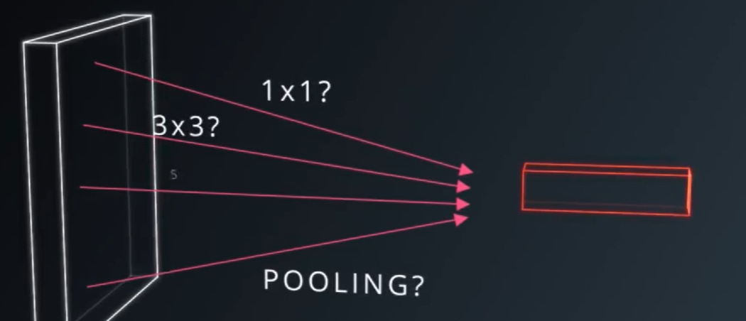

* El foloseste o combinatie de 1x1, 3x3 Convolution etc.

Si le concateneaza:

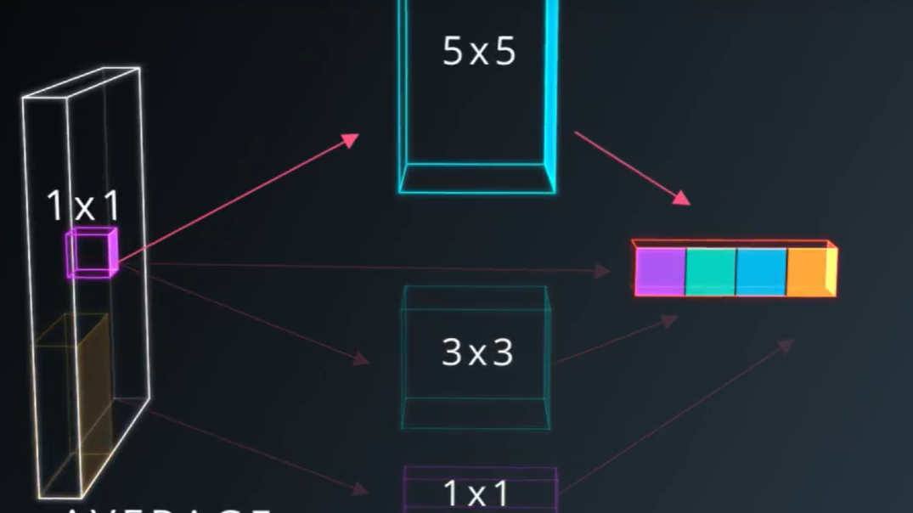

* Aplicand si Average
* In felul asta reduce super mult numarul de parametrii. Treaba intereseanta, este ca poti alege acesti parametrii, in asa fel incat numarul total de parametrii din modelul tau sa fie foarte mic.

**Convolutional Neural Network in Tensorflow**

Code download link: https://d17h27t6h515a5.cloudfront.net/topher/2017/February/58a61ca1_cnn/cnn.zip

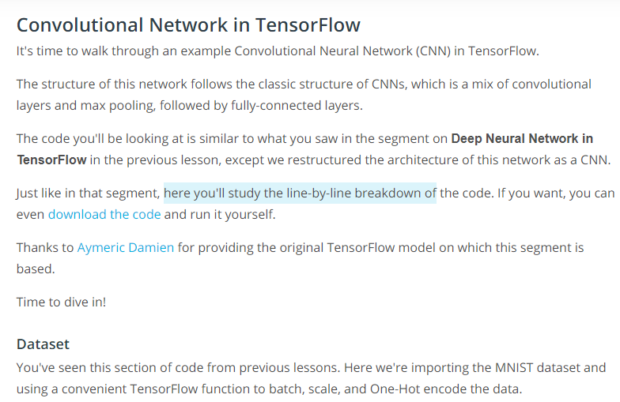

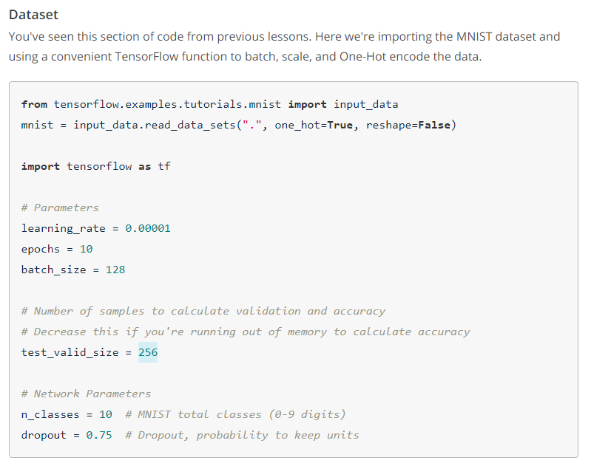

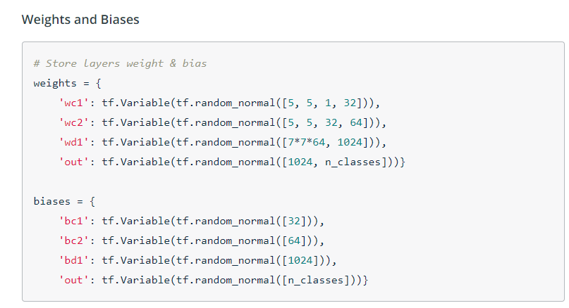

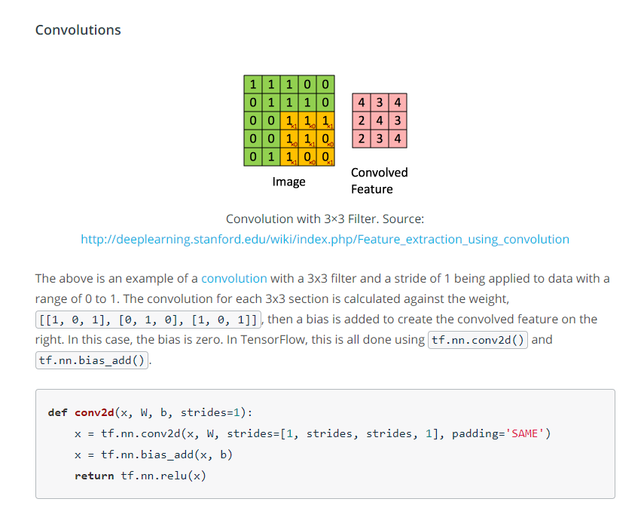

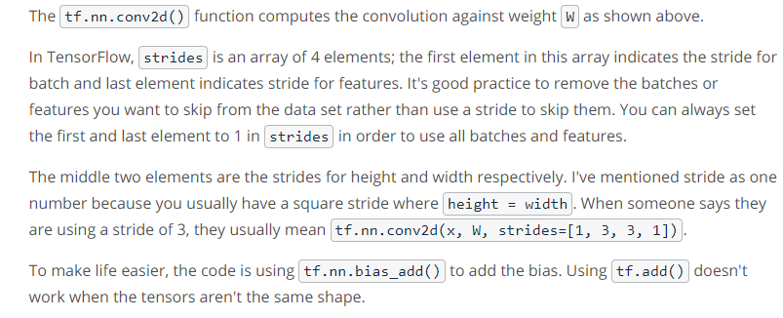

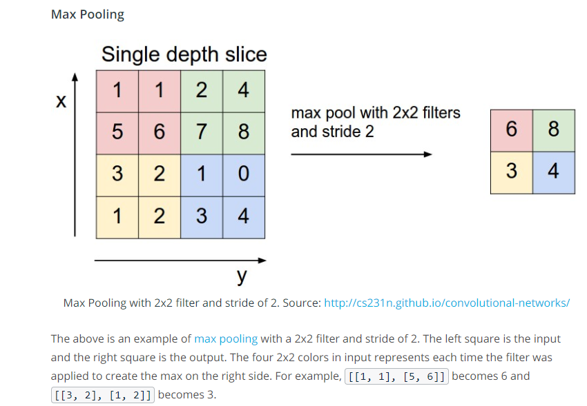

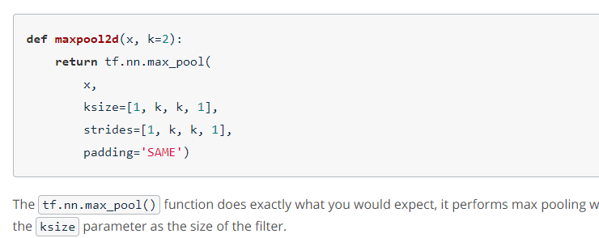

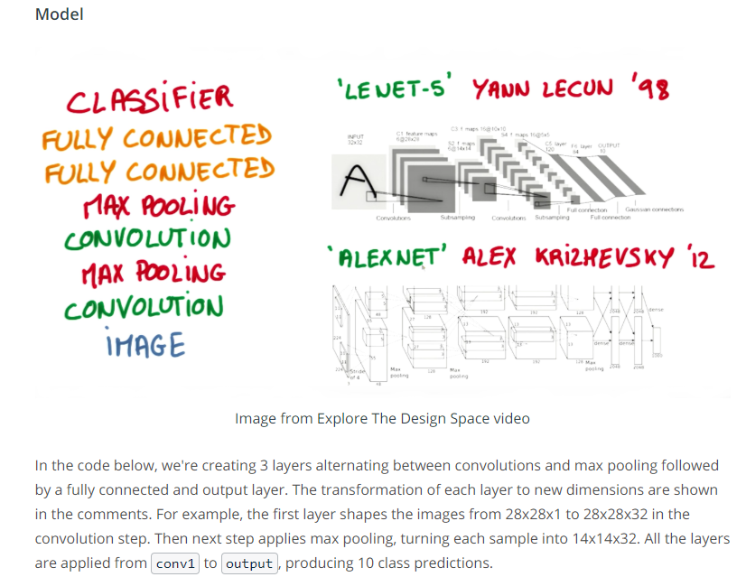

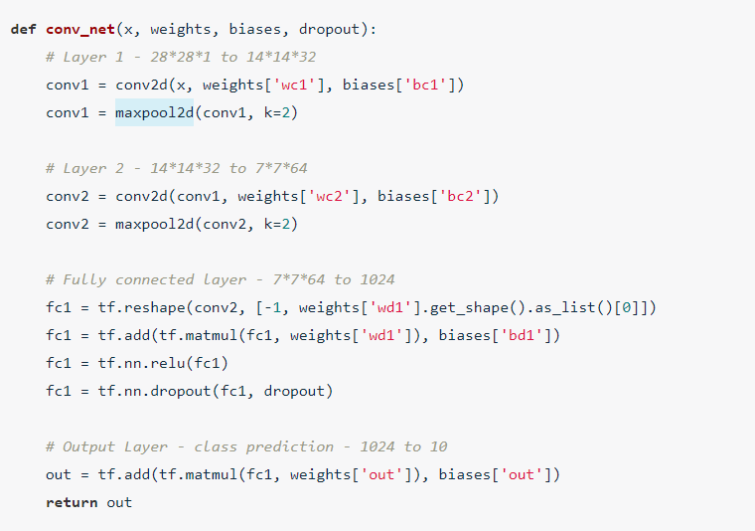

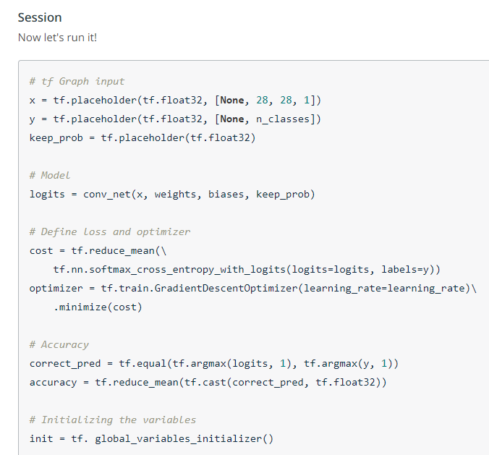

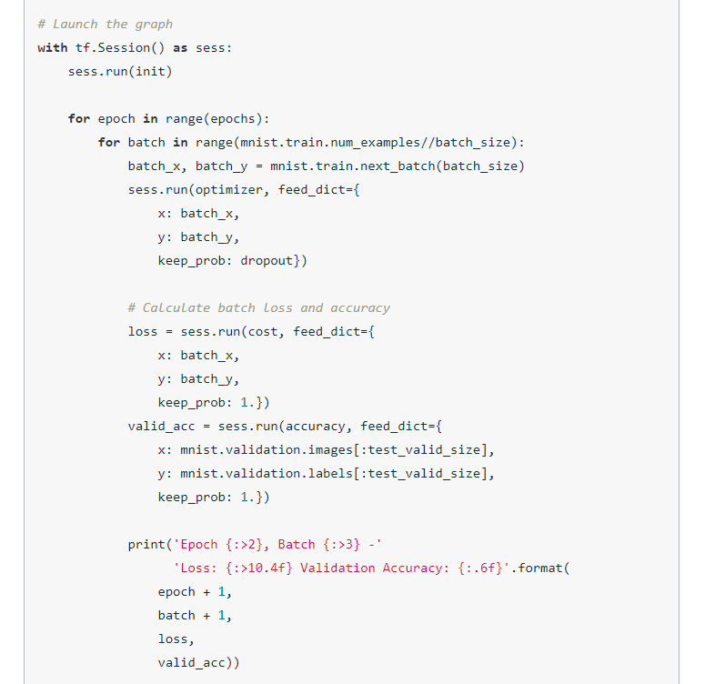

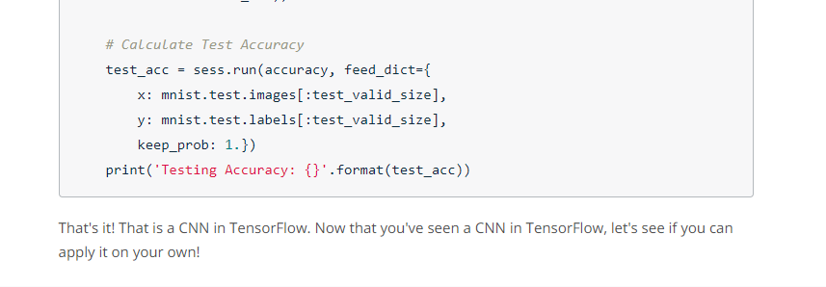

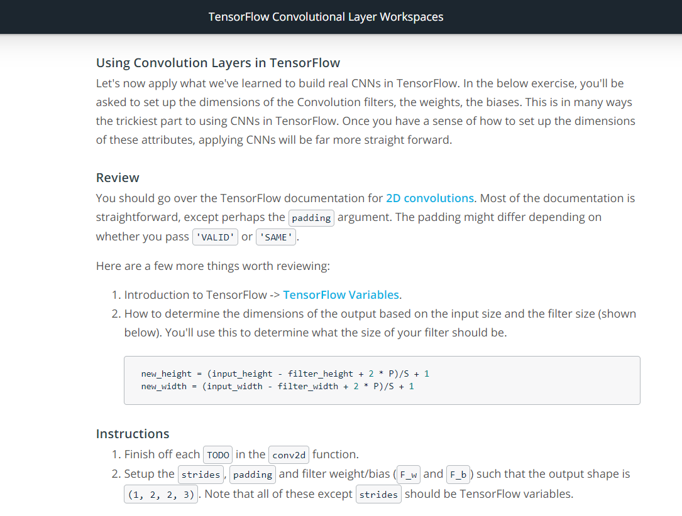

Link 2D convolutions: <https://www.tensorflow.org/guide#Convolution>

Link TF Variables: <https://www.tensorflow.org/guide/variable>

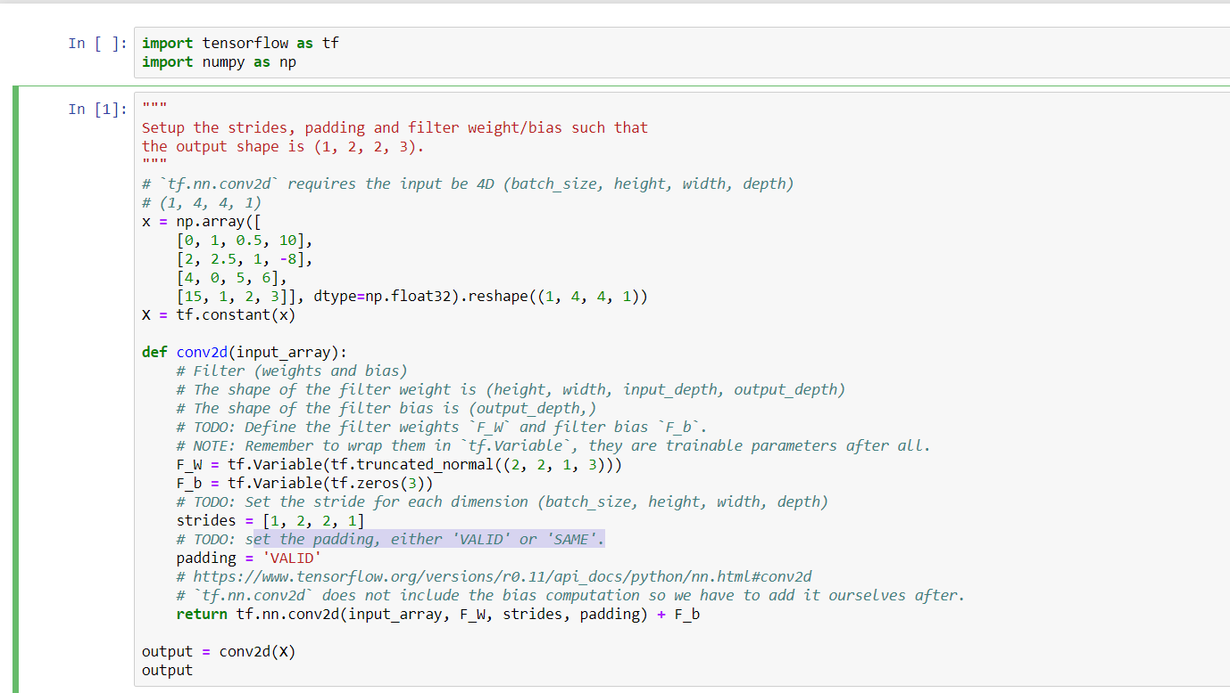

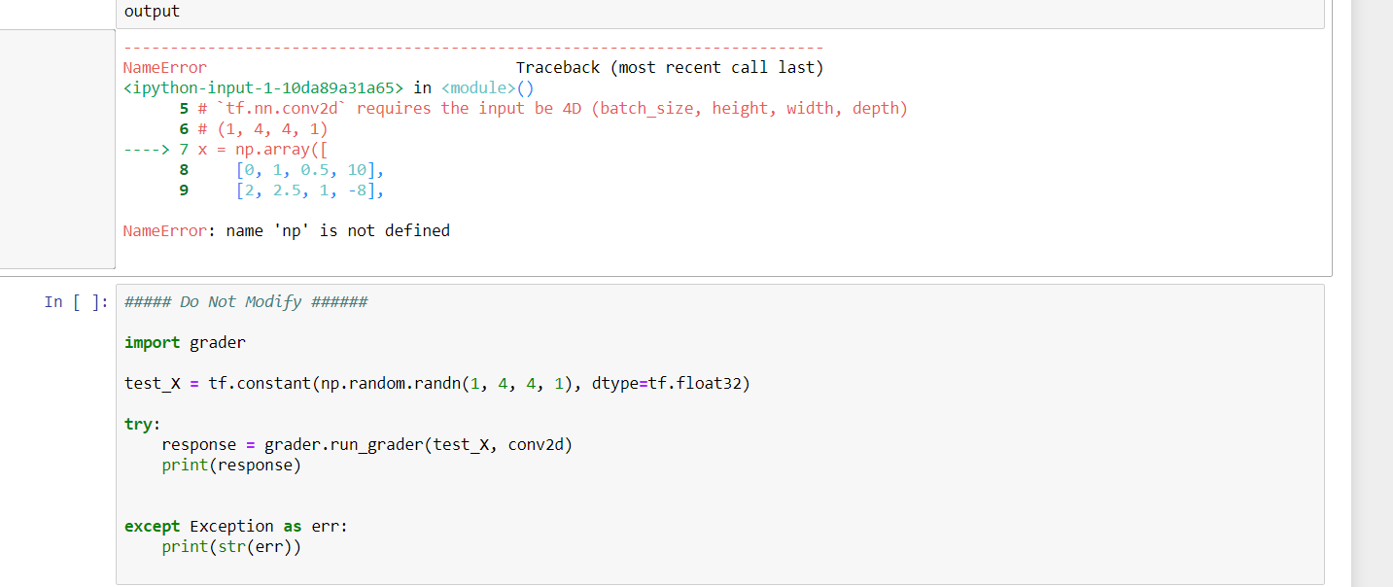

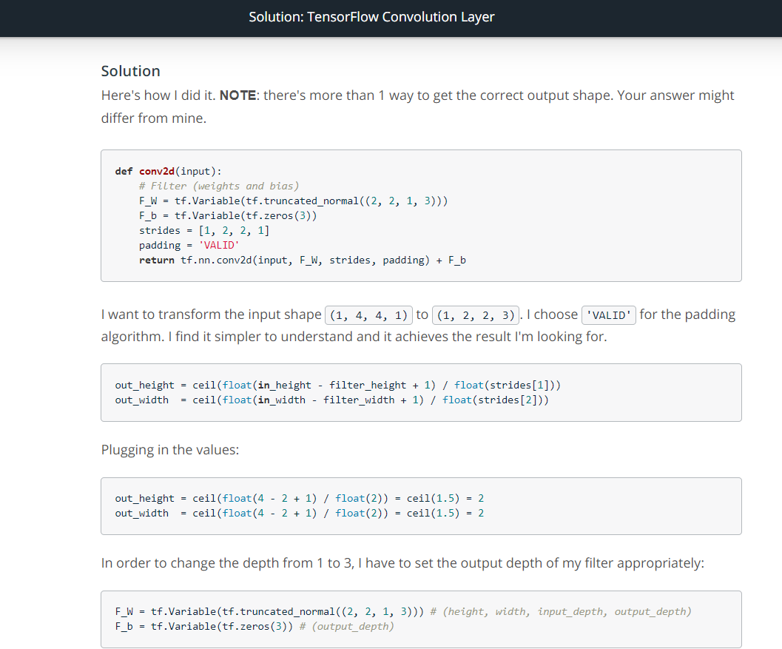

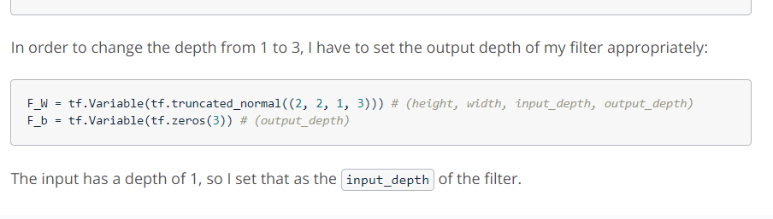

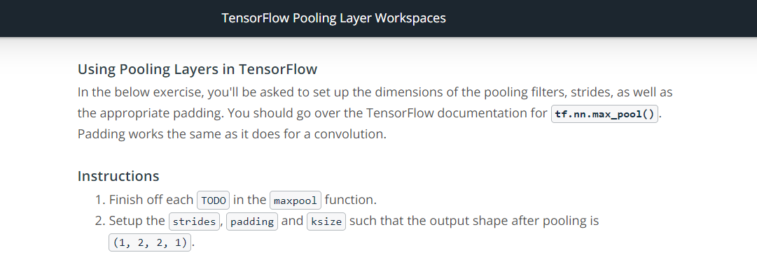

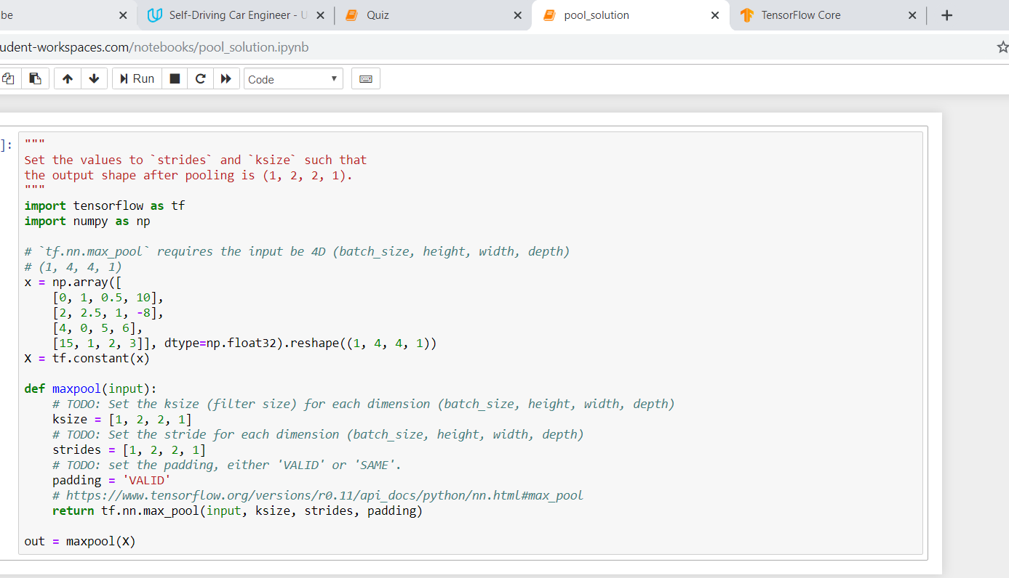



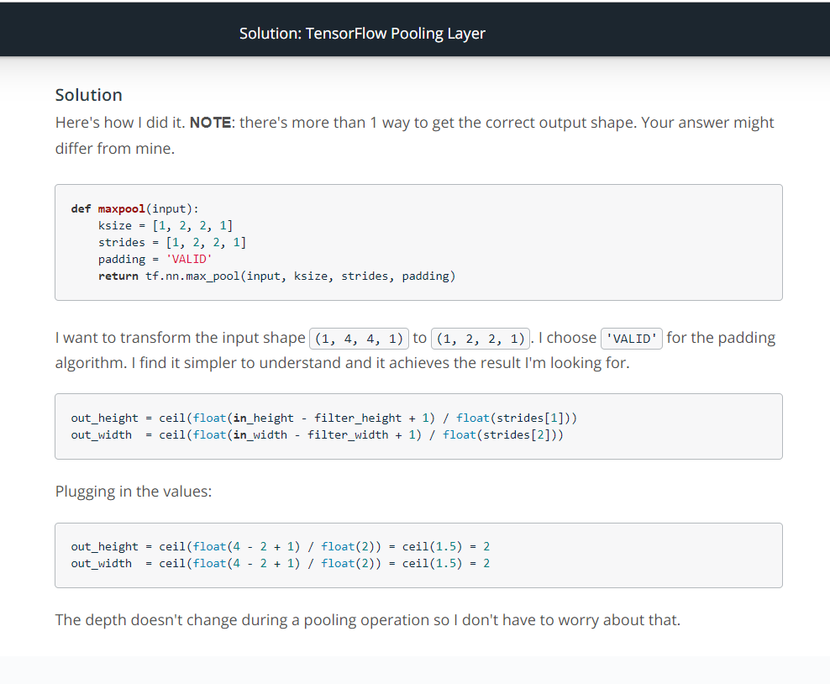

**Lab: LeNet in Tensorflow**

LeNet link: <http://yann.lecun.com/exdb/publis/pdf/lecun-98.pdf>

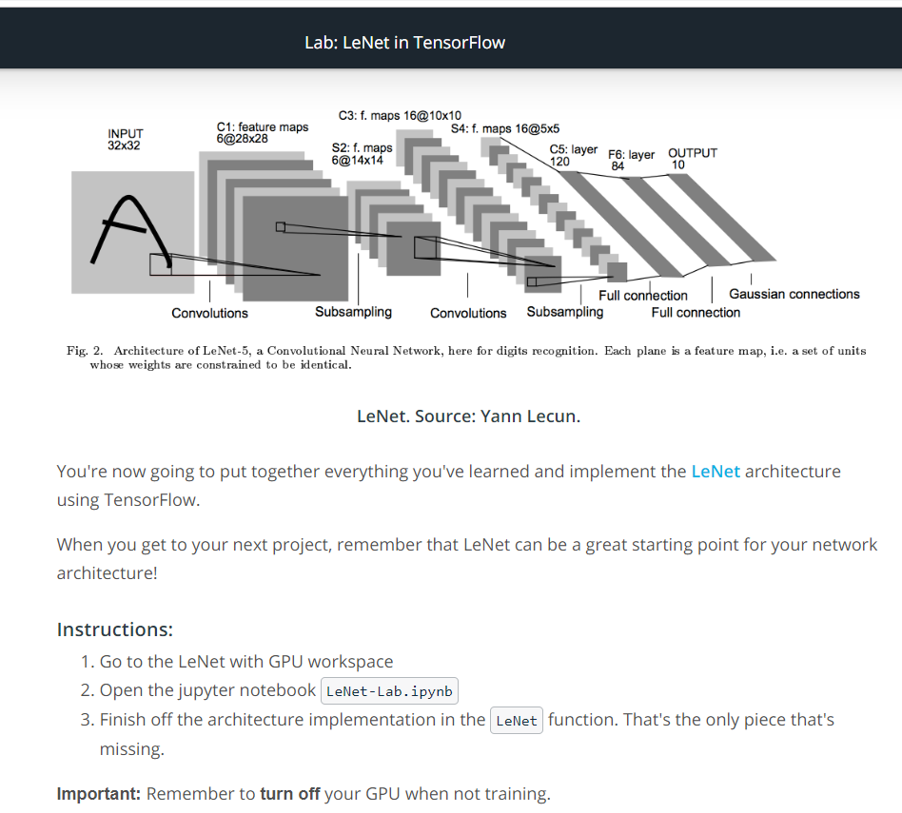

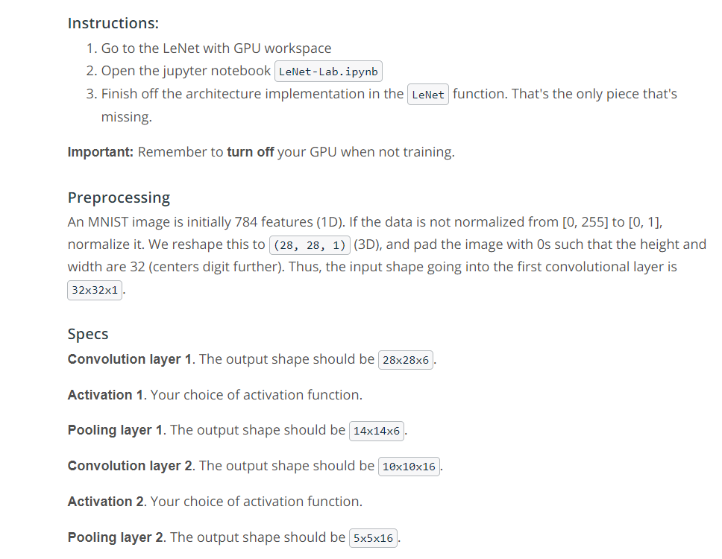

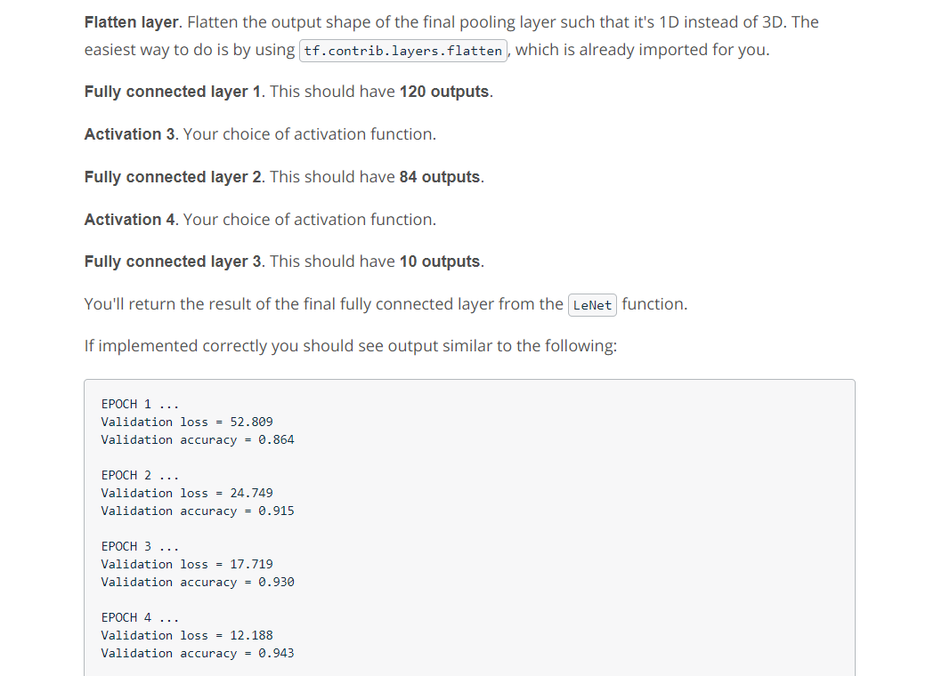

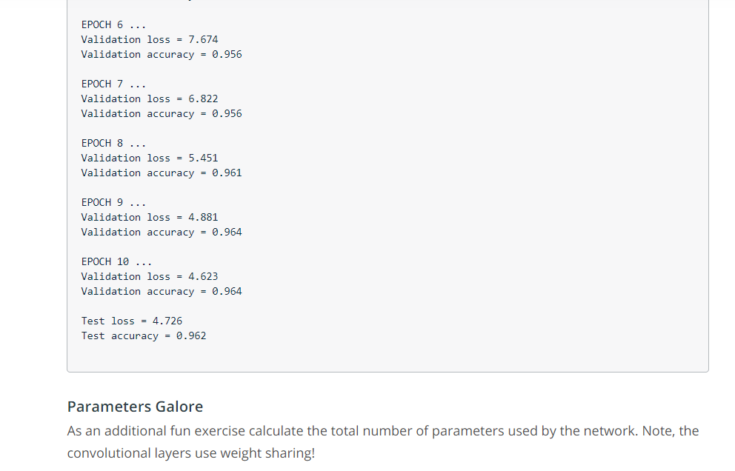

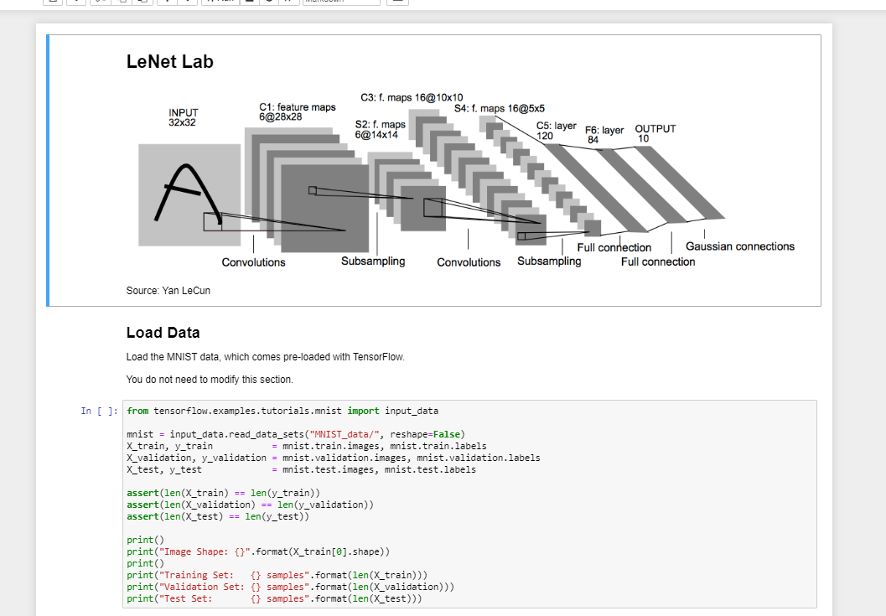

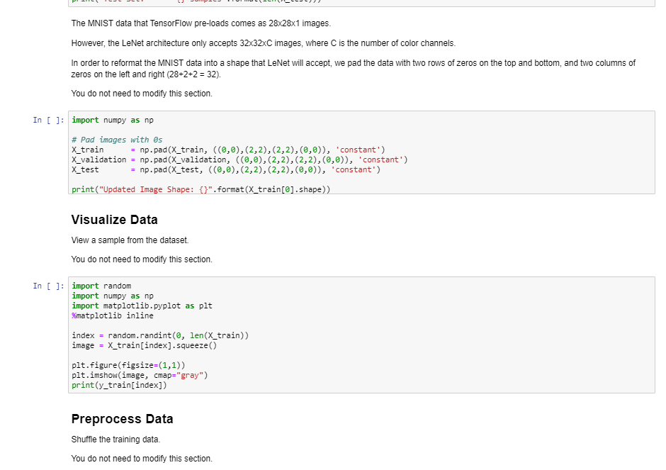

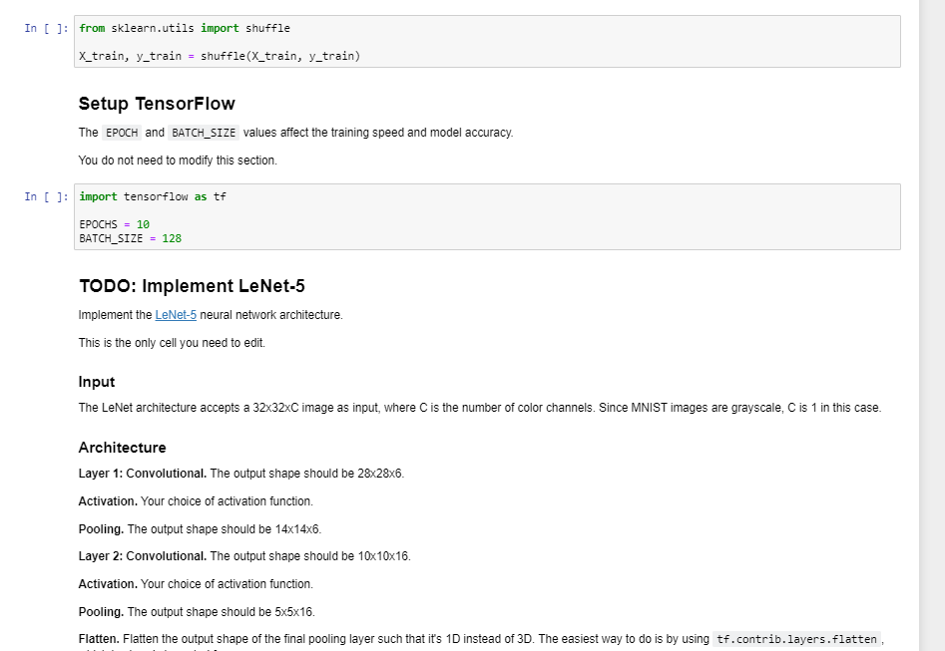

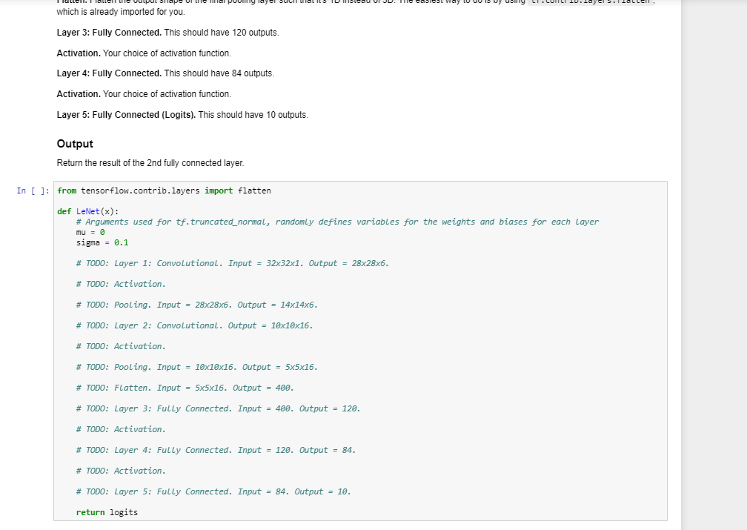

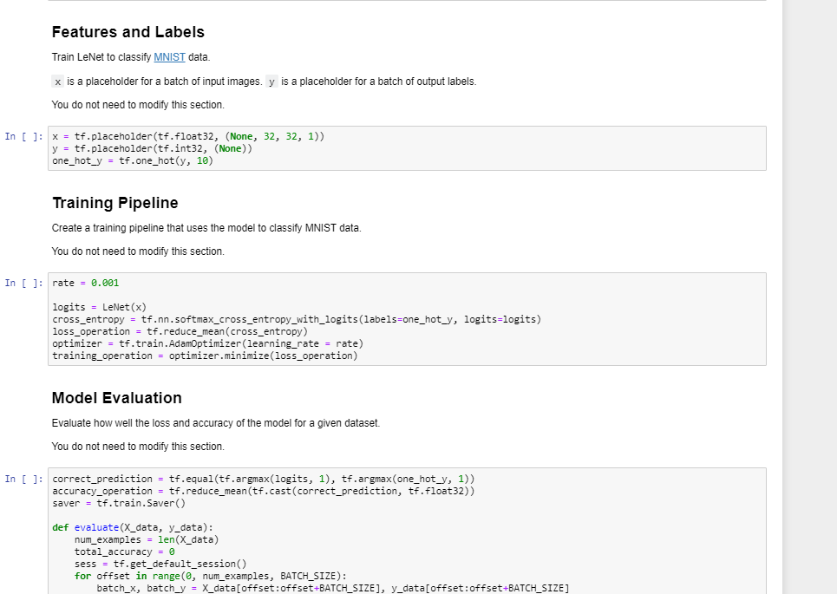

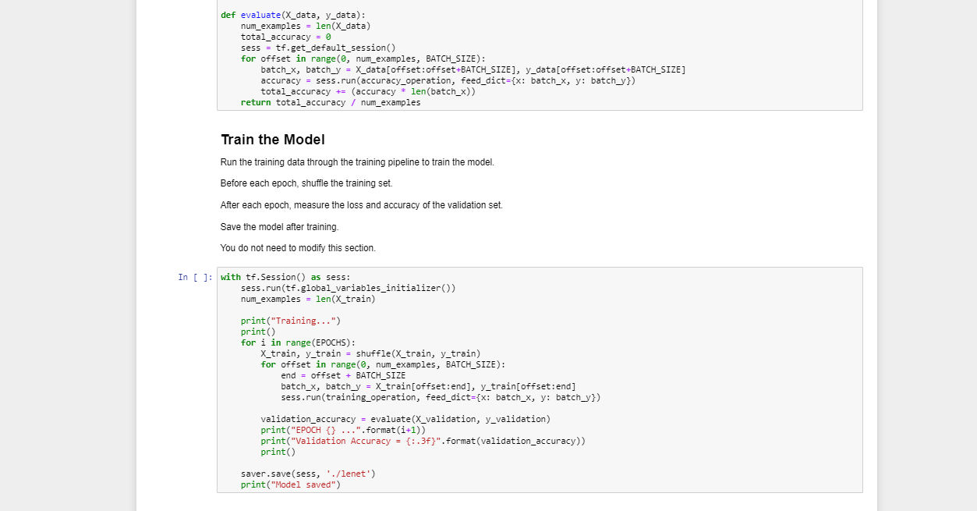

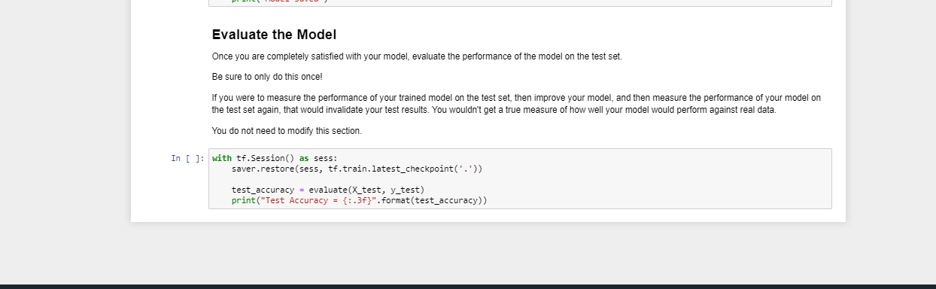



Link 1: <http://cs231n.github.io/>

Link2: <http://neuralnetworksanddeeplearning.com/>

Link3: <http://www.deeplearningbook.org/>